http://latimesblogs.latimes.com/money_co/2009/07/pope-benedict-xvi-is-offering-a-solution-for-what-ails-the-global-economy-a-true-world-political-authority-to-manage-it-al.html

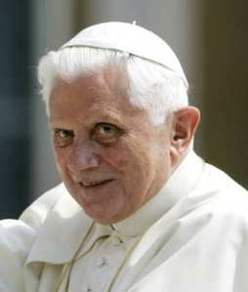

« Previous Post | Money & Company Home | Next Post »
Pope urges 'world authority' to govern economy, finance
July 7, 2009 | 5:31 pm

Pope Benedict XVI is offering a solution for what ails the global economy: a "true world political authority" to manage it all.

In a so-called encyclical published today -- just as leaders of the world’s biggest economies gather in central Italy for a summit -- Benedict mostly focuses on his ideas for achieving "justice and the common good" in the modern economy.

His basic themes are well-traveled, including fairness to workers, the evils of "excessive" wealth disparities and regard for the environment.

But then he ventures onto controversial turf, suggesting that the authority to fix all of this be vested in global governing bodies, including the United Nations.

The pope writes:

In the face of the unrelenting growth of global interdependence, there is a strongly felt need, even in the midst of a global recession, for a reform of the United Nations Organization, and likewise of economic institutions and international finance, so that the concept of the family of nations can acquire real teeth.

To manage the global economy; to revive economies hit by the crisis; to avoid any deterioration of the present crisis and the greater imbalances that would result; to bring about integral and timely disarmament, food security and peace; to guarantee the protection of the environment and to regulate migration: for all this, there is urgent need of a true world political authority, as my predecessor Blessed John XXIII indicated some years ago.

Such an authority would need to be regulated by law, to observe consistently the principles of subsidiarity and solidarity, to seek to establish the common good, and to make a commitment to securing authentic integral human development inspired by the values of charity in truth.

Many of Benedict’s ideas might have been viewed as roadblocks to progress during the global economy’s boom years, but his message no doubt will resonate today with many people worldwide who believe that unbridled capitalism has been ruinous.

He has choice words for the world’s financiers:

Finance, therefore -- through the renewed structures and operating methods that have to be designed after its misuse, which wreaked such havoc on the real economy -- now needs to go back to being an instrument directed towards improved wealth creation and development. Insofar as they are instruments, the entire economy and finance, not just certain sectors, must be used in an ethical way so as to create suitable conditions for human development and for the development of peoples.

Financiers must rediscover the genuinely ethical foundation of their activity, so as not to abuse the sophisticated instruments which can serve to betray the interests of savers.

-- Tom Petruno

Photo: Pope Benedict XVI. Credit: Pier Paolo Cito / Associated Press

