https://www.thoughtco.com/tiberius-roman-emperor-121262
The Roman Emperor Tiberius (November 16, 42 B.C.–March 16, 37 A.D.) was a very capable military leader and a sensible civic leader who tried to restrain Rome's out-of-control budget. But he was also dour and unpopular. He is known primarily for his trial for treason, sexual perversion, and eventually shirking his responsibility by going into seclusion.
https://en.wikipedia.org/wiki/Tiberius
While Tiberius was in Capri, rumours abounded as to what exactly he was doing there. Suetonius records the rumours of lurid tales of sexual perversity, including graphic depictions of child molestation, and cruelty, and most of all his paranoia.
Why did the CDC, Headed by a Jesuit (known for their approval of 'boy love' trained Dr. Robert Redfield, name their National Database for Tracking your ENTIRE HISTORY OF VACCINATIONS--TIBERIUS?
https://www.alemattec.com/National-Institute-of-Health,-NIH,-Dr.-Francis-Sellers-Collins-is-Dr.-Anthony-Fauci's-boss-and-'claims'-to-be-a-FORMER-Roman-Catholic-.-.-..doc
https://www.cdc.gov/vaccines/adults/vaccination-records.html
Your vaccination record (sometimes called your immunization record) provides a history of all the vaccines you received as a child and adult. This record may be required for certain jobs, travel abroad, or school registration. See on this page, highlighted for you, Tiberius . . .
https://scdhec.gov/news-releases/dhec-continues-provide-covid-19-vaccine-updates-latest-information
https://en.wikipedia.org/wiki/Tiberius_Julius_Abdes_Pantera
Celsus' work was lost, but in Origen's account of it Jesus was depicted as the result of an affair between his mother Mary and a Roman soldier. He said she was "convicted of adultery and had a child by a certain soldier named Pantera".[1] Tiberius Pantera could have been serving in the region at the time of Jesus's conception.[1] Both the ancient Talmud and medieval Jewish writings and sayings reinforced this notion, referring to "Yeshu ben Pantera", which translates as "Jesus, son of Pantera". The hypothesis is considered unlikely by mainstream scholars given that there is little other evidence to support Pantera's paternity outside of the Greek and Jewish texts.[2][3]

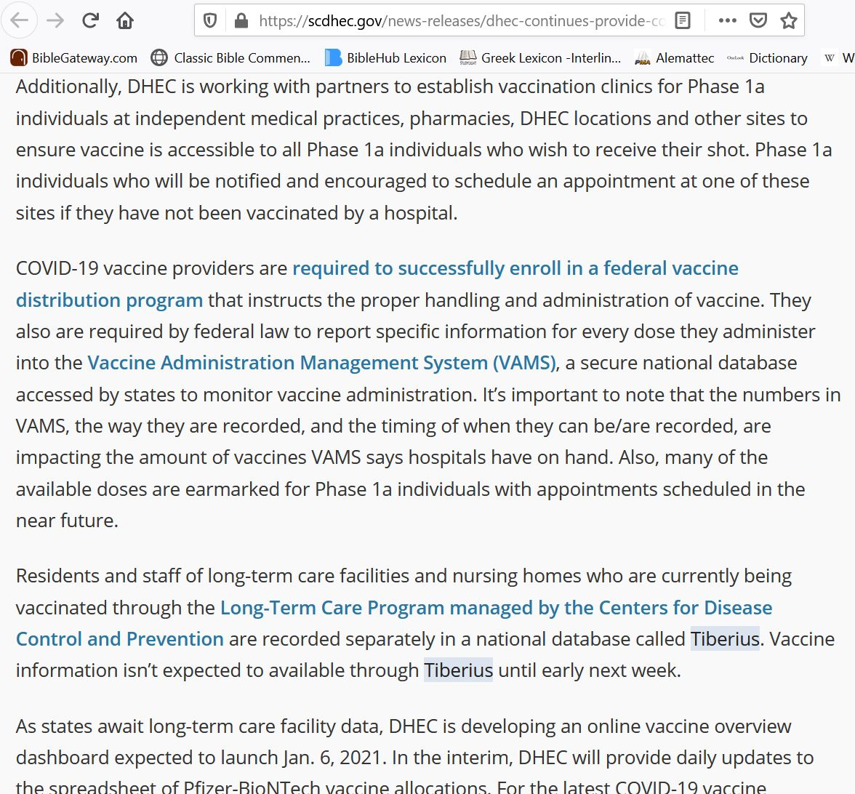

https://medalerts.org/
Searched for the word Tiberius on CDC's WEB site had eight hits:
https://search.cdc.gov/search/?query=Tiberius&sitelimit=&utf8=%E2%9C%93&affiliate=cdc-main
MAYBE, JUST MAYBE, THIS IS REFERRING TO YET ANOTHER TIBERIUS!
Tiberius Julius Abdes Pantera
https://en.wikipedia.org/wiki/Tiberius_Julius_Abdes_Pantera
Celsus' work was lost, but in Origen's account of it Jesus was depicted as the result of an affair between his mother Mary and a Roman soldier. He said she was "convicted of adultery and had a child by a certain soldier named Pantera".[1] Tiberius Pantera could have been serving in the region at the time of Jesus's conception.[1] Both the ancient Talmud and medieval Jewish writings and sayings reinforced this notion, referring to "Yeshu ben Pantera", which translates as "Jesus, son of Pantera". The hypothesis is considered unlikely by mainstream scholars given that there is little other evidence to support Pantera's paternity outside of the Greek and Jewish texts.[2][3]

Tiberius Platform Aids COVID-19 Logistics, Delivery
Dec. 16, 2020 | BY LISA SIMUNACI, OFFICE OF THE SECRETARY OF DEFENSE PUBLIC AFFAIRS
https://www.defense.gov/Explore/News/Article/Article/2446061/tiberius-platform-aids-covid-19-logistics-delivery/
While Star Trek's Capt. James Tiberius Kirk said he grew tired of explaining the origins of his middle name, Operation Warp Speed officials are eager to highlight their version of Tiberius — a software platform designed to guide the distribution of a COVID-19 vaccine.
(Captain James Tiberius Kirk, middle name Tiberius, named after Tiberius Caesar Augustus, the second Roman Emperor, https://redshirtsalwaysdie.com/2021/01/03/star-trek-james-kirk-middle-name-different/). Oh, the sadistic, gay, child molester. Sure, let's name his character after that guy.
Tiberius was specifically developed for Operation Warp Speed — the collaborative effort led by the Department of Health and Human Services and the Defense Department to develop, manufacture and deliver safe and effective COVID-19 vaccines to Americans.
Incorporating information from a multitude of sources including the U.S. Census, Vaccine Tracking System and commercial logistics companies, Tiberius provides visibility of each effort within Operation Warp Speed — from manufacturing and allocation of vaccine to granular planning of vaccine administration sites to the provider level.
The jurisdictions — 64 U.S. states, territories and large metropolitan cities — work inside the Tiberius platform to decide where their allocated doses will go, from local doctors' offices to large medical centers. These decisions are then sent to distributors to deliver vaccines across the country.
At the beginning of distribution, vaccine availability will be limited. Jurisdictions will be allocated doses based on their census-derived percentage of the U.S. population over the age of 18. As more vaccines become available from the manufacturers, Operation Warp Speed will continue to run the algorithm each week to determine how much vaccine each jurisdiction will receive.
Jurisdictions will determine, based on guidance from the Food and Drug Administration and emergency use authorization along with recommendations from the Centers for Disease Control and Prevention and the Advisory Committee on Immunization Practices, how to prioritize the administration of vaccines.
"The federal government is running the algorithm, but the states will make the decision as to where the doses go, and we will comply with their decision and get those doses to the final destination," said Paul Mango, the deputy chief of staff for policy at HHS.
While it receives data from several outside systems, all of the information coming into Tiberius is de-identified, and no personal identifying or personal health information comes into the platform. Tiberius integrates the data related to manufacturing, supply chain, allocation, state and territory planning, delivery and administration of both vaccine products and kits containing needles, syringes and other supplies needed to administer the vaccine.
With information from both federal and local sources, Tiberius can provide a zip code-by-zip code view of priority populations, including frontline workers and nursing home residents.
Tiberius provides planning tools for states to optimize their allocation and distribution plans. Based on priority recommendations, Tiberius provides decision support to leaders around the country, drawing from the data which includes planning information provided by jurisdictions.
Once the vaccine ships, Tiberius will also be used to provide information updates for jurisdictional partners, said Deacon Maddox, Operation Warp Speed chief of plans, operations and analytics.
"Like most of America, public health professionals are working through the challenges brought on by quarantines, telework and social distancing," Maddox said. "While the pandemic stresses both people and systems, our expertise and technology tools provide a disciplined and deliberate approach to prioritize vaccine delivery and ease the burden of public health officials throughout the nation."
Tiberius came into full use over Labor Day weekend, and the federal government provided training materials for its users at the jurisdiction level. A help desk is available, as well as dedicated information technology personnel funded by HHS for each jurisdiction to address technical or training issues users experience with the system.
Either way, I don't want anything at all to do with it; also, I believe no Christian should want anything to do with it either.

Kentucky backs players' right to kneel after local cops burn gear in protest
https://sports.yahoo.com/kentucky-backs-players-right-to-kneel-after-local-cops-burn-gear-in-protest-052523461.html

Note: I don't watch professional sports anymore because of this. Looks like College basketball is now off my watch list.

10 FACTS You Must Know About The Jesuits!
https://prepareforchange.net/2019/11/05/10-facts-you-must-know-about-the-jesuits/

LGBT Jesuit Priest Says Bible May Be Wrong About Homosexuality
https://www.breitbart.com/faith/2019/10/24/lgbt-jesuit-priest-says-bible-may-be-wrong-about-homosexuality/
The Jesuits are Now Actively Promoting Homosexuality
http://www.zephaniah.eu/index_htm_files/The%20Jesuits%20are%20Now%20Actively%20Promoting%20Homosexuality.pdf

Daily Beast Drops Bombshell about Jesuits
https://www.americanthinker.com/blog/2015/02/daily_beast_drops_bombshell_about_jesuits_.html

--
Paul (<:) Jesus first!
www.Alemattec.com

