Linda Yaccarino
Yaccarino is the Chairman of the World Economic Forum’s Taskforce on Future of Work, and the Chair of the Advertising Council's Board of Directors. She sits on Ascena Retail Group’s Board of Directors.
https://www.mmaglobal.com/speakers/linda-yaccarino
Ad Council Announces New Members of Board of Directors
https://www.mediavillage.com/article/ad-council-announces-new-members-of-board-of-directors/
Ad Council is "America's leading non-profit organization dedicated to using communications to drive social change."
According to their website, the Ad Council is a non-profit organization that uses "donated ad space and airtime" and "produces, distributes and promotes campaigns that improve everyday lives." Our memorable work inspires ongoing dialogue, engagement and action around significant public issues, creating a measurable difference in society."

Pope Francis Pushes Covid Vaccines
From an Ad Council press release dated August 18, 2021 titled "Pope Francis Joins the Ad Council and COVID Collaborative’s “It’s Up To You” Campaign to Inspire Confidence in the COVID-19 Vaccines"
Ad Council's Gay Web Page, 'About Us.'
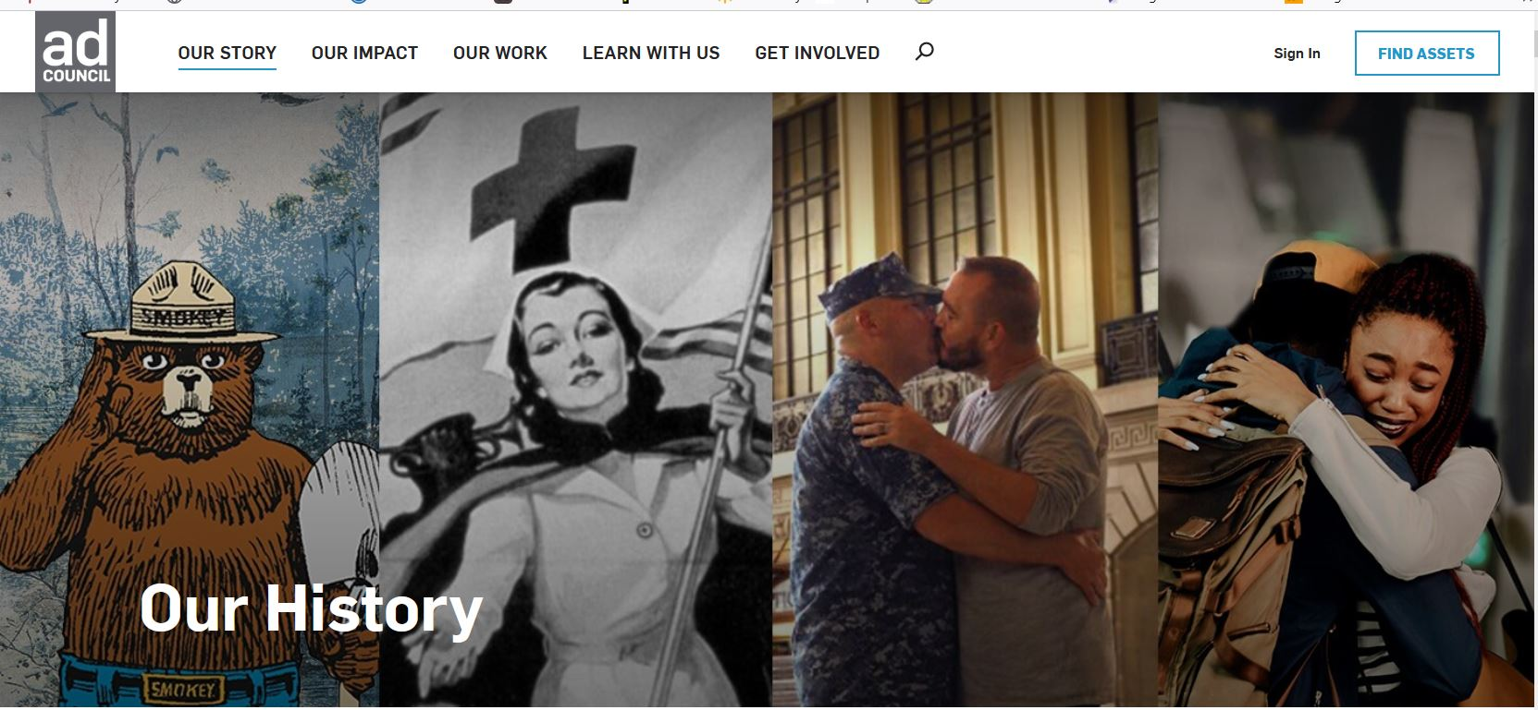
Former Presidents and First Ladies ‘It’s Up To You’ :60 | Ad Council and COVID Collaborative
https://www.youtube.com/watch?v=eCza6UGmRTk

Campaigns using the Southern Poverty Law Center
The Ad Council has worked on several campaigns with the Southern Poverty Law Center.
The Southern Poverty Law Center supports a wide variety of extreme-liberal positions; it is against conservative Christianity, pro-immigration (both legal and illegal), advocates multiculturalism and the homosexual agenda, supports Muslims and racial preferences and defendants' rights, and advocates against what it considers 'hate groups.'
The SPLC's op-ed writings have appeared in the Communist Party USA's newspaper People's World. SPLC has been criticized in mainstream press for being extravagant in its spending, and often uses charges of 'racism' to stifle conservatives. Despite the organization's far-left (Communist) partisanship and its slander of mainstream conservative and Christian organizations, the mainstream media continues to cite the SPLC as an 'authority' against what they call hate groups. 02SEP22 . . .
SPLC Works (Partners closely with) WOKE, Corrupt, anti-American Federal Bureau of Investigation, F.B.I.
Hate Crimes--FBI (RECENT, SCRUBBED VERSION--Removed their 'Partnership' with Communist Southern Poverty Law Center, SPLC)
What We Investigate
https://www.fbi.gov/investigate/civil-rights/hate-crimes
ARCHIVED VERSION, August 7 2018. Hate Crimes--FBI (ARCHIVED VERSION--SHOWING THE F.B.I.'s 'Partnership' with Corrupt, Communist Southern Poverty Law Center, SPLC)
What We Investigate
https://web.archive.org/web/20180807014331/https://www.fbi.gov/investigate/civil-rights/hate-crimes
Southern Poverty Law Center, SPLC, Working to Promote Marxist (Communist) Black Lives Matter (Their WEB site is hidden in their name-- www.learningforjustice.org).
SPLC--Black Lives Matter Week of Action Learning for Justice
https://www.learningforjustice.org/magazine/black-lives-matter-week-of-action
Obama Nominates a Justice, Pro-Family Groups Respond
https://familypolicyalliance.com/issues/2016/03/16/obama-nominates-a-justice-pro-family-groups-respond/
“The Obama administration has demonstrated it cannot be trusted…”
(Corrupt, Communist) Merrick Garland is President Obama’s nominee to the U.S. Supreme Court to fill the vacancy left by the death of Antonin Scalia.

Then, because of the above Christian Group speaking out about Communist Barack HUSSEIN Obama corrupt, Merrick Garland and his treat to America's Freedoms, the Communist Southern Poverty Law Center, SPLC, goes after 18 Christian Groups.
SPLC’s 10-page attack was distributed to 55,000 police officers in America. Called 18 Anti-Gay Groups and Their Propaganda, it encourages police to especially watch the hateful, violence-inciting propaganda from Christian/conservative "watchdog" organizations. These include the American Family Association, Concerned Women for America, Family Research Council, Coral Ridge Ministries, Liberty Council, and Traditional Values Coalition.
According to Dr. Gary Cass, who is affiliated with the Christian Anti-Defamation Commission, "To say that anybody who has a principled objection to homosexuality [and warns of] the impact that that sinful lifestyle has on individuals and on society is somehow morally equivalent to overt racism and violence is absolutely defamatory."

SPLC's 18 Anti-Gay Groups and Their Propaganda
https://www.splcenter.org/fighting-hate/intelligence-report/2010/18-anti-gay-groups-and-their-propaganda

CNN Investigation Hits Darkest Secret of Merrick Garland’s Career
'Has the unraveling of the ‘Fedsurrection’ narrative opened the door to a much overdue reassessment of what really happened in Oklahoma City? ... '
https://headlineusa.com/cnn-investigation-hits-darkest-secret-of-merrick-garlands-career/

Southern Poverty Law Center, SPLC, Promotes Communist Malcolm X . . .
SPLC--Malcolm X Beyond the Mythology
https://www.learningforjustice.org/podcasts/teaching-hard-history/civil-rights-movement/malcolm-x-beyond-the-mythology

Malcolm X and the
communist movement
The following is the 11th in a series of excerpts the Militant is running from Pathfinder Press’s latest book, Malcolm X, Black Liberation, and the Road to Workers Power, by Jack Barnes, national secretary of the Socialist Workers Party. We encourage our readers to study and discuss the book. This excerpt is from the chapter “Black Liberation and the Dictatorship of the Proletariat.” Subhead is by the Militant.
https://www.themilitant.com/2010/7413/741358.html
New York meeting pays tribute to Betty Shabazz (Communist Wife of Malcolm X) And Shabazz pays tribute to Her Communist Friends
https://www.themilitant.com/2010/7413/741353.html
On Page #16 of Archive As the Original Source From Democratic Socialists of America
https://www.dsausa.org/dl/fall2k.pdf was scrubbed:

Archive version:
https://web.archive.org/web/20120108173459/http://www.dsausa.org:80/dl/fall2k.pdf
On Page #16.
p a g e 1 6 ï D e m o c r a t i c L e f t ï F a l l 2 0 0 0
Fannie Lou Hamer
Dear DSA:
I was quite puzzled by the name
Fannie Lou Hamer that was added to
the Harrington Institute. Who is
Fannie Lou Hamer? Has she ever been
a member of DSOC or DSA? I feel
strongly that the institute should only
carry Harringtonís name, our founder
and intellectual leader. I am sure that
Fannie was a fine person, but I see ab-
solutely no reason to add her name to
the institute.
DON FANDETTI
Columbia, MD
Fannie Lou Hamer was a civil rights leader,
activist, and member of Mississippiís ìFree-
dom Democratic Partyî delegation to the 1964
Democratic National Convention, the Afri-
can-American group that attempted to bring
a more socialist-oriented stance to the Demo-
cratic platform. Her inclusion in the name of
the Institute adds racial and gender diversity,
and marries two historic strains of the Ameri-
can Democratic Left.
Along with Communist Fannie Lou Hamer, Communist Gloria Richardson (Co-Chairman of the Cambridge Nonviolent Action Committee, CNAC,) and her daughter worked with Communist Student Nonviolent Coordinating Committee (SNCC).
Gloria Richardson, fighter for Black rights, Freedom Now Party (Socialist, i.e.: Communist Web site)
Gloria Richardson, a leader of the fight to desegregate Cambridge, Maryland, was a collaborator with Communist Malcolm X
https://themilitant.com/2021/08/07/gloria-richardson-fighter-for-black-rights-freedom-now-party/

In Memoriam: "Glorious Gloria's" Fearless Leadership of the Cambridge Nonviolent Action Committee
https://kinginstitute.stanford.edu/memoriam-glorious-glorias-fearless-leadership-cambridge-nonviolent-action-committee

4 things to know about new Twitter CEO Linda Yaccarino
https://www.marketwatch.com/story/4-things-to-know-about-new-twitter-ceo-linda-yaccarino-37a7c2ee
Diversity, Equity and Inclusion (DEI)
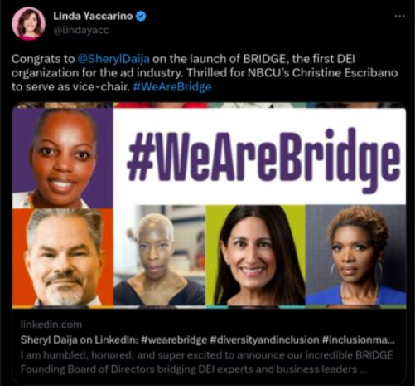
Linda Yaccarino is a Diversity, Equity and Inclusion (DEI) advocate. According to her bio: "At NBCU, she uses the power of media to advance equity and helps to launch Diversity, Equity and Inclusion, 'DEI-focused' initiatives..."

What is Diversity, Equity and Inclusion (DEI)?

Critical Race Theory’s (You know, Communist, racists that hate America, hate white people, destroy America's foundations, hate Christians, yea that Critical Race Theory) new disguise (DEI) or JEDI
https://unherd.com/2021/10/critical-race-theorys-new-disguise/

From DEI to JEDI
https://www.diverseeducation.com/opinion/article/15109001/from-dei-to-jedi

Twitter hires law firm denounced by CEO Elon Musk
https://www.reuters.com/legal/transactional/twitter-hires-law-firm-denounced-by-ceo-elon-musk-2023-01-05/

'Elon Musk breaks Twitter silence with photo with Pope'--France24 (July 2, 2022)
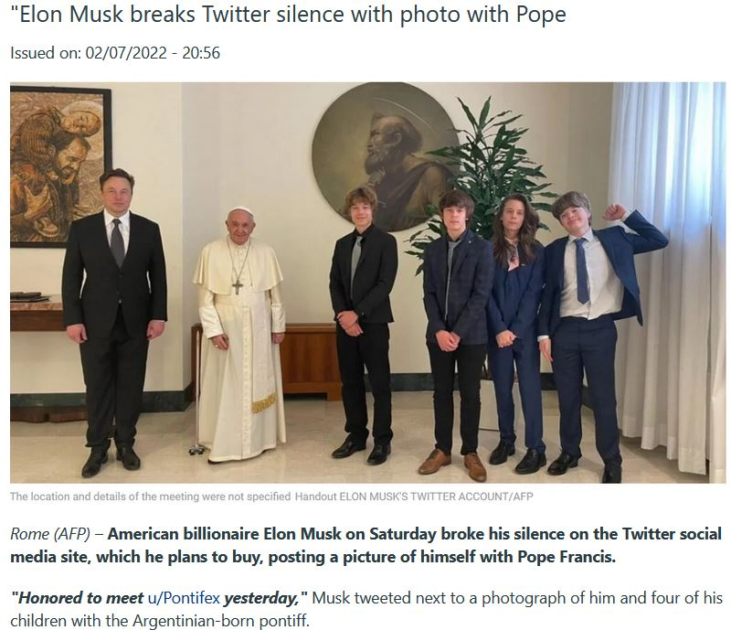
New Twitter CEO Linda Yaccarino and her family are Roman Catholics (that hide their religious belief or allow people to speculate that she is 'Christian'. Linda Yaccarino worked with Pope Francis to promote dangerous Covid 19 vaccines, she is a member of the Jesuits World Economic Forum, W.E.F..
Elon Musk yet again reveals himself to being a controlled opposition fraud. He is not a threat to the Roman Catholic beast system (The Roman Catholic Controlled world system, the "New World Order,") and never will be.
(Jesuit trained) Trump Names NBCU's Linda Yaccarino to the President's Council on Sports, Fitness and Nutrition
The appointment comes hours after Trump slammed NBC on Twitter
https://www.adweek.com/convergent-tv/trump-names-nbcus-linda-yaccarino-to-the-presidents-council-on-sports-fitness-and-nutrition/
Elon Musk Names NBCU, Ad Council, W.E.F. Linda Yaccarino As Twitter's New CEO--'We Should Have Known!' May 12, 2023.

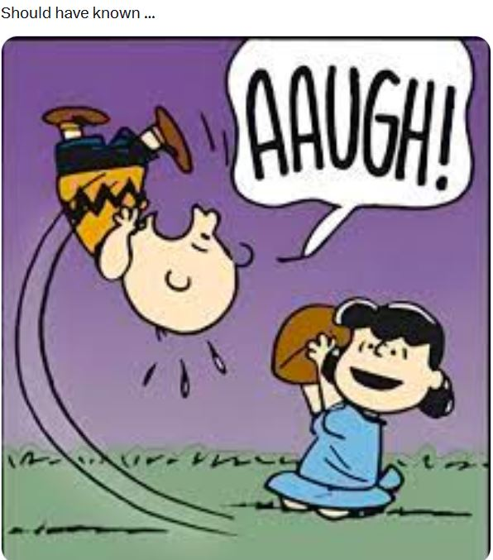

Tucker Carlson says he’s coming back with show on Twitter
https://apnews.com/article/tucker-carlson-twitter-show-fox-news-a1ededbd4ade8ea1c86265aa2747d2c4

The Jesuits’ plan to compensate their slaves’ descendants gets reparation wrong
https://qz.com/2010943/georgetown-and-the-jesuits-slavery-reparations-plan-falls-short

--
Paul (<:) Jesus first!
www.Alemattec.com

