Jimmy Carter, satanic, antiChristian, Communist should have no respect shown for both selling the Panama Canal, but more importantly, for turning his back on Israel and supporting an antiChristian terrorist group Hamas. In so doing, supporting Hamas, he proved to be antiChristian by denying the Abrahamic Covenant. The Abrahamic Covenant is still in effect:
Genesis 12, 13-17; Revelation 5, 7; Jeremiah 31:31-40; Matthew 26:25-29; Mark 14:18-25; Hebrews 8-13
What Is the Abrahamic Covenant?
The Abrahamic Covenant is really the beginnings of the formal revelation of the covenant of grace, of God's decision to reach into humanity and specifically save people for Himself.
https://www.christianity.com/wiki/bible/what-is-the-abrahamic-covenant.html
Why Does God Refer to Himself as the God of Abraham, Isaac, and Jacob?
When God appeared to Moses through the burning bush, he called himself "the God of Abraham, Isaac, and Jacob." Why would God use this name? In fact, this name tells us something vital about God's nature.
https://www.christianity.com/wiki/god/why-does-god-refer-to-himself-as-the-god-of-abraham-isaac-and-jacob.html
Why Was Abraham Chosen to be the Father of All Nations?
It was Abraham’s steadfast faith, his unquestioning obedience, and his constant seeking of God that is believed to be the reason why God chose Abraham to be the first patriarch of the Hebrews, and ultimately the rest of the nations.
https://www.christianity.com/wiki/bible/why-was-abraham-chosen-to-be-the-father-of-all-nations.html

What Is a Covenant? - Biblical Meaning and Importance Today
One of the main features that we see throughout the Bible is covenants. Covenants are not exactly contracts. A covenant is a relationship, but it is a relationship that has been formalized and has been brought under sanctions.
https://www.christianity.com/wiki/bible/what-is-a-covenant-biblical-meaning-and-importance-today.html
https://www.Alemattec.com/Barack HUSSEIN Obama's Beige suit . . . a signal to Muslims 'change is coming' . . . Former President Jimmy Carter now promotes Islamic Sharia Law . . . .doc
Jimmy Carter Promotes Sharia for the Islamic Society of North America (ISNA)
https://web.archive.org/web/20140906235228/https://www.youtube.com/watch?v=XdzwHA6-bZA
Jimmy the Baptist: Carter redefined ‘evangelical,’ from campaigns to race and women’s rights
https://ca.news.yahoo.com/jimmy-baptist-carter-redefined-evangelical-144612758.html

Jimmy Carter to meet Raul Castro, religious leaders in Cuba
https://www.dnaindia.com/world/report-jimmy-carter-to-meet-raul-castro-religious-leaders-in-cuba-1525004

Jimmy Carter slams Israel in pro-Palestine op-ed
https://www.washingtontimes.com/news/2014/aug/5/jimmy-carter-slams-israel-in-pro-palestine-op-ed/

President Carter, am I a Christian? (From His Answers, No.)
How literally do you take the Bible, including miracles like the Resurrection?
https://www.dallasnews.com/opinion/commentary/2017/04/17/president-carter-am-i-a-christian/

Jimmy Carter: America Must Recognize Palestine
By Jimmy Carter
- Nov. 28, 2016

https://archive.ph/1vd49#selection-691.0-691.46

America forfeited its greatest seaway—to what end?
By Abraham Blondeau • September 7, 2022
https://www.thetrumpet.com/26101-the-panama-canal-the-gate-of-his-enemies-nbsp

The Rise and Fall of a Superpower
Building the Panama Canal was one of the greatest chapters in American history. It helps to reveal how America became a superpower, if we understand the complete history. Today we see an almost totally different spirit in our leaders. The meaning behind that change contains the strongest warning ever for America!
By Gerald Flurry
https://www.thetrumpet.com/221-the-rise-and-fall-of-a-superpower
American taxpayers funded the canal project to its completion. The finished project included port facilities at both the Pacific and Atlantic ends of the canal, three major locks and all associated equipment to power, operate and maintain these facilities. As President Reagan stated, “We bought it, we paid for it, it’s ours, and we are going to keep it.”
He had been pre-empted, however, by President Jimmy Carter, who, in 1977, concluded dubious “treaties” with President Omar Torrijos of Panama, promising to give the canal to Panama at noon on December 31, 1999. The fact that two thirds of the American people were opposed to these “treaties” did not faze President Carter at the time. Subsequent research has thrown doubt on whether the treaties were legal within the context of both the U.S. and Panama constitutions.
Even though two thirds of the American people were opposed, Mr. Carter undemocratically led us into a shameful treaty!
The undemocratic process continues. Now we surrender the canal when most of the Panamanian people don’t even want us to leave. That is because they understand the danger better than our leaders do!
Is this the act of a superpower?
History clearly demonstrates the kind of spirit and courage it takes to build a superpower. But we are ignoring this history; American leaders are naively dismantling the number-one superpower in a world full of tigers.
Still, this descent goes even deeper than our history books could ever reveal.

Carter Visits Pope in Vatican, Reaffirms Stand on Rights
https://www.washingtonpost.com/archive/politics/1980/06/22/carter-visits-pope-in-vatican-reaffirms-stand-on-rights/dac8a284-7889-451d-9cb1-8c3e26bf4c3e/

UNITED STATES PRESIDENT JIMMY CARTER MEETS POPE (June 21-23, 1980)
https://www.youtube.com/watch?v=nwoQcMFXzz8

American Presidents Bowing The Knee To The 'pope' aka – The Holy See
https://history.state.gov/departmenthistory/travels/president/holy-see
Note: People Came To See The King, The King Didn't Go To An Inferior. A Greater King Never Went To See An Inferior King. The Inferior King Always Traveled And Presented Himself To The Superior King. Same Thing Today. Heads Of Nations Go To The Vatican, Normally Not The Other Way Around. The 'Holy See' The Pope Is Sovereign, Monarch, King, Over The Vatican And The Roman Catholic 'church'. People Bow To His Authority By Seeking An Audience With Him.

All religions which are in fact false religions, including false Christian Pretenders, e.g. Roman Catholics, Mormons, Jehovah Witness, etc, especially Charismatic Pretenders --Matthew 7, Verses 13–27
https://www.Alemattec.com/All religions which are in fact false religions, including false Christian Pretenders, e.g. Roman Catholics, Mormons, Jehovah Witness, etc, especially Charismatic Pretenders --Matthew 7_13–27.htm

Former President Jimmy Carter And Wife Rosalynn Posing With Communists Thomas Moore (2nd from right) And Alex Garrett (far right.), May 7, 2018

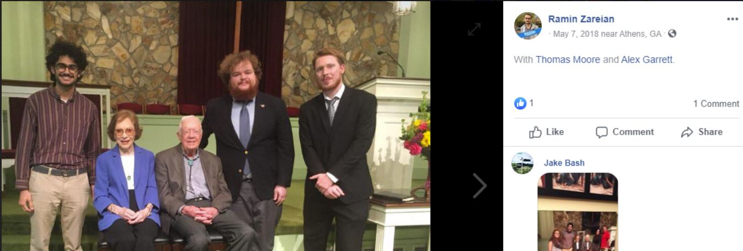

Communist Fans Of Former President Jimmy Carter, May 7, 2018—Alex Garrett, far left, Rebecca Wilson, second from right, and Thomas Moore, far right

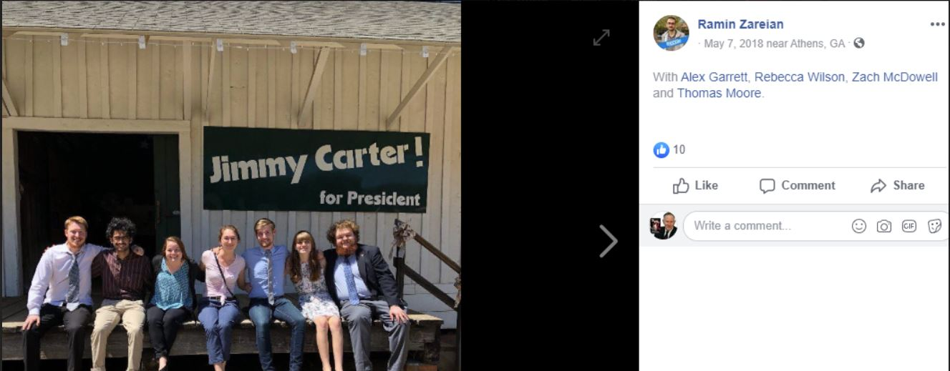

Paul (<:')

--
Paul (<:) Jesus first!
www.Alemattec.com

