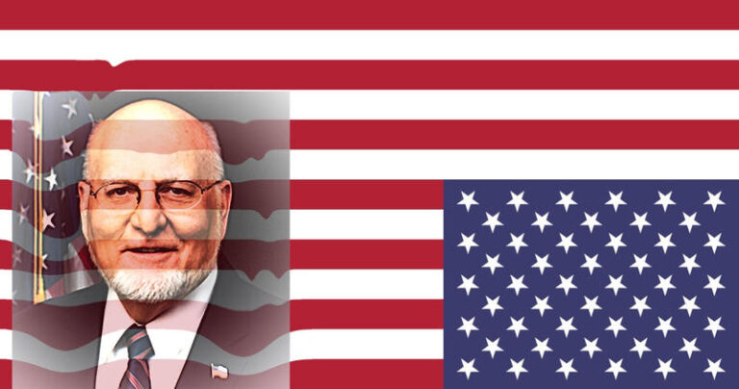
Two Jesuit Physicians are deceiving the United States of America -- Dr. Anthony Fauci and Dr. Robert Redfield -- while at the same time their head, the one that rules them, the "pope" of Rome -- "pope" Francis, deceiveth the whole world by them.
Revelation 13:8
8 And all that dwell upon the earth shall worship him, whose names are not written in the book of life of the Lamb slain from the foundation of the world.
Note: Worship who? The antiChrist. The "pope" of Rome, the papacy, "pope" Francis.
Dr. Robert Redfield, Head of the Center for Disease Control, CDC, is an active member of Baltimore’s Cathedral of Mary Our Queen.
Dr. Robert Redfield was born and raised in a Roman Catholic family. Both of his parents worked at the National Institutes of Health (NIH).

Alumni in the Field: Robert Redfield
https://alumni.georgetown.edu/news/gumc/magazine/2019/fall-winter/alumni-field-robert-redfield
After receiving his medical degree from (Jesuit) Georgetown in 1977, Redfield pursued his residency and fellowship at Walter Reed Army Medical Center and had his first assignment within research in 1982. His task was to study viruses which could cause significant problems for active duty military personnel, either through blood transmission or as a sexually transmitted disease. He spent much of his time learning about a new syndrome called AIDS. All active duty personnel diagnosed with AIDS and their families were referred to Walter Reed, and Redfield became their primary physician.

CDC director ‘not shy about his Catholic faith,’ says Baltimore pastor
https://cruxnow.com/church-in-the-usa/2020/03/cdc-director-not-shy-about-his-catholic-faith-says-baltimore-pastor/

No wonder much concern arose when President Trump appointed Dr. Redfield to lead the CDC.

CDC woes bring Director Redfield's troubled past as an AIDS researcher to light
https://www.cnn.com/2020/06/04/politics/cdc-redfield-aids-walter-reed-army-investigation/index.html

Trump’s Pick for CDC Director Is Experienced But Controversial
On the face of it, veteran virologist Robert Redfield seems like a good pick to lead the agency, but decades-old disputes are shadowing his appointment.
https://www.theatlantic.com/science/archive/2018/03/trumps-pick-for-cdc-director-is-experienced-but-controversial/556202/
In the first year of his administration, Donald Trump has repeatedly filled important scientific positions with candidates who seem to be either unqualified for the roles or diametrically opposed to the very purpose of those roles. Scott Pruitt was chosen to lead the Environmental Protection Agency after having repeatedly sued it. Rick Perry became Secretary of Energy, heading a department that he formerly wanted to eliminate and that he couldn’t remember the name of. Sam Clovis, a now-withdrawn nominee for chief scientist at the United States Department of Agriculture, had no scientific background. Brenda Fitzgerald seemed a reasonable choice to direct the Centers of for Disease Control and Prevention (CDC) but was forced to resign after Politico reported that she had bought shares in a tobacco company shortly after taking up her post.
But Redfield has not escaped the controversy that has dogged other Trump-era appointees. In the mid-1990s, Redfield oversaw a clinical trial of an experimental HIV vaccine at the Walter Reed Army Institute of Research. He was accused of manipulating data from the trial, “sloppy or, possibly, deceptive” data analysis, and overstating results in a number of talks and publications. After an investigation, the military cleared Redfield of misconduct charges, but as Jon Cohen reported for Science at the time, the Army never provided an explanation of how it reached its conclusions.
Despite clearing him, military investigators chastised Redfield for having a “close relationship” to a nonprofit called Americans for Sound AIDS/HIV Policy (ASAP) “to a degree that is inappropriate.” ASAP, now known as the Children’s AIDS Fund, was founded by evangelical Christians; it has championed abstinence-only education as a method of combating HIV and other approaches grounded more in religious belief than scientific evidence.

The origins of an investigation
But behind closed doors, a scandal was unfolding. Roughly a week after giving his presentation in Amsterdam, Redfield was confronted by colleagues who claimed the data he had presented was misleading. During a meeting at a Walter Reed facility in Rockville, Maryland, according to a researcher in the room, a heated discussion broke out when a researcher working under Redfield, Army Maj. Dan Lucey, argued that what Redfield had presented in Amsterdam didn't match the data.
According to a source familiar with the meeting, Redfield angrily defended his work. Also present at the meeting was Redfield's research assistant at the time, Dr. Deborah Birx. Redfield had brought Birx over to his lab in 1988, shortly before beginning the vaccine treatment for HIV. According to their peers at the time, they were seen as a unit, working in tandem on the gp-160 testing.

Why Trump's new CDC director is an abysmal choice
https://www.cnn.com/2018/05/13/opinions/trumps-terrible-choice-for-cdc-redfield-garrett/index.html
(CNN)The US Centers for Disease Control and Prevention has a new boss, Dr. Robert Redfield, who ignited controversy because of his dubious qualifications for the job and the over-the-top salary offer that came with it. Initially slated to earn $375,000 a year, Redfield faced questions from Democrats, led by Sen. Patty Murray of Washington, and last week agreed to work for $209,700 instead.
I scrutinized nearly 1,000 pages of payroll listings at the Department of Health and Human Services, and found few CDC employees who earn more than $150,000 annually. Some make considerably more than that, thanks to Title 42, a policy that gives federal agencies flexibility on salary limits in order to lure outstanding scientists and other professionals into government work.
Nearly all of those scientists are classified as Medical Specialists, 138 of whom earn more than $250,000. All but 13 work at the National Institutes of Health, engaging in basic scientific research.
Just two individuals make more than $350,000, ranking them the most highly paid federal employees after the President (who is paid $400,000): Anthony Fauci, director of the National Institute of Allergy and Infectious Diseases, and Rachel Sherman, deputy commissioner of the Food and Drug Administration. Having run NIAID since 1984, Fauci is the longest serving Institute director in NIH history. He has been an adviser to five presidents, architect of the HIV program PEPFAR, the 24th most-cited scientist in history and recipient of every major biomedical award besides the Nobel Prize, including the Presidential Medal of Freedom and the National Medal of Science.

Jesuit-trained Dr. Anthony Fauci says 'Certificates of Immunity,' 'Immunity Cards,' -- 'Internal Passports' are possible . . . might have some merit, 10 APR 2020 . . .
http://www.alemattec.com/BILL-GATES-PANDEMIC,-David-Rockefeller,-Eli-Broad,-George-Soros,-Ted-Turner,-Oprah,-Michael-Bloomberg-and-others.htm

President Donald J. Trump, Jesuit trained, and his wife Melanie kneel (worship) at the Roman Catholic Shrine of s'AINT' John Paul, II in Washington, D.C.
http://www.alemattec.com/Jesuit-trained-President-Donald-Trump-along-with-his-Roman-Catholic-wife-Melania-kneel-at-Roman-Catholic-shrine-of-s'aint'-John-Paul-II.htm
http://www.alemattec.com/Chinese-Wuhan-Coronavirus-Covid-19-CONTROLLED-PLANNED-deceiveth-the-whole-world,-Revelation-12,-vs.-9-11.htm
--
Paul (<:) Jesus first!
www.Alemattec.com

