Note: If you are using OpenOffice, you will need to click on File, Page Preview.
Rick Warren's Saddleback "churches" Men’s Bible group, Rick Warren being one of the most influential "Pastors" in the Southern Baptist Convention—was studying the mythology of Word Faith prosperity teacher Joyce Meyer as early as August of 2011.
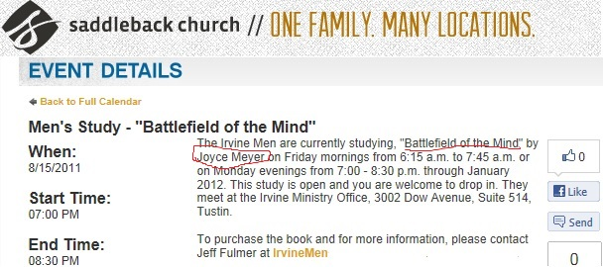
Note: See Joyce Meyers, preaching, that Christians are “little gods.” See what God declares in His Word, by following the link here: www.alemattec.com/Secular humanism has displaced the Judeo-Christian world view.doc
Dr. LaVerne Adams, a spiritually whacked out Word Faith flake "pastor" who also goes by the name called . . . "The Doctor of Destiny," wrote a book called Driven by Destiny: 12 Secrets to Unlock Your Future had its foreword written by . . . you guess it, Rick Warren.
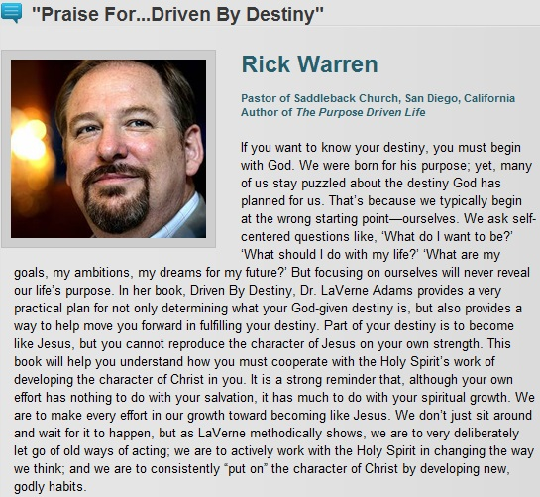
Rick Warren, "pastor" of Saddleback "church," San Diego, California
Author of Purpose Driven LIE, i.e.: sorry he calls it Purpose Driven Life.

Driven By Destiny: 12 Secrets to Unlock Your Future
http://www.amazon.com/Driven-Destiny-Secrets-Unlock-Future/dp/0982208820/ref=sr_1_1?s=books&ie=UTF8&qid=1286925964&sr=1-1
This person, is like the whacked out person, marleneloves1, a "faith healer" who is "minister" whose prayers bring forth miracles, and here quotes Holy Scripture after Holy Scripture, out of context, and claims if you touch your computer screen along with her "prayer" you will be healed of all disease, including cancer. Marleneloves1 prays that God would "reverse the curse" and she commands light to enter into people and heal them.
http://www.youtube.com/watch?v=Nf97X6jSHlA
The "Doctor of Destiny" Dr. LaVerne Adams tells us in that God brought into her life the mighty “prayer general” Dr. Cindy Trimm:
"As a catalyst to move me into a realm of power and faith that delivered me into a "deeper dimension of my divine destiny…". As an ambassadorial mouthpiece for God, Dr. Trimm’s dynamic style, cutting-edge prayer stategies, and kingdom technologies has profoundly aligned me to take dominion and prosper in every area of my life.
Because of her unique passion to see me empowered to reach my fullest potential my life is royally positioned as a resource that advances the establishment of the Kingdom of God.
Not only that, but who knew that Dr. Cindy Trimm is also “an ambassadorial mouthpiece for God” with such “kingdom technologies” that the female "pastor" the "Divine" Doctor Destiny Adams is now so fine-tunedly and “aligned” she’s able “to take dominion and prosper.”
The mighty “prayer general” Dr. Trimm also raves about "pastor" Dr. LaVerne Adams herself:
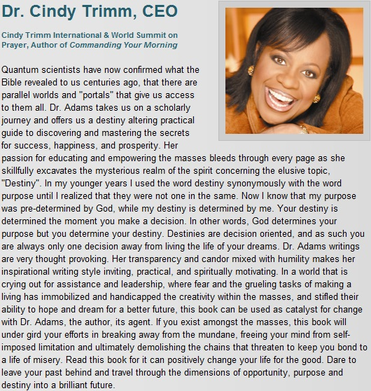
Note: "God determines your purpose but you determine your destiny". -- Dr. Cindy Trimm, CEO. In other words, you're really in charge, you take control, God's plan for one's life doesn't matter, just His purpose for that life, as it's up to the individual to determine their own destiny. God's not in charge, you are. Not!
Joshua 24:20
20 If ye forsake the Lord, and serve strange gods, then he will turn and do you hurt, and consume you, after that he hath done you good.
Proverbs 4:2
2 For I give you good doctrine, forsake ye not my law.
Jeremiah 6:16
16 Thus saith the Lord, Stand ye in the ways, and see, and ask for the old paths, where is the good way, and walk therein, and ye shall find rest for your souls. But they said, We will not walk therein.
Of God's family, of His world, God works His good pleasure causing us to well :
Philippians 2:13
13 For it is God which worketh in you both to will and to do of his good pleasure.
Note: A most sure and grounded argument against pride, as God's good pleasure comes from the free gift of God, and is outside of us, for we do not have ability nor the power, so much as to will to do well (much less to do well), except only by the free Mercy of God. We do not will to do well by our sinful nature, but only because God has made of our wicked will a good will.
Hebrews 13:20-21
20 Now the God of peace, that brought again from the dead our Lord Jesus, that great shepherd of the sheep, through the blood of the everlasting covenant,
21 Make you perfect in every good work to do his will, working in you that which is wellpleasing in his sight, through Jesus Christ; to whom be glory for ever and ever. Amen.

www.alemattec.com/Kenneth Hagin, Joyce Meyer, Kenneth Copeland, Creflo Dollar, Benny Hinn False Teachings EXPOSED.htm

--
Paul (<:) Jesus first!
www.Alemattec.com

