POWER. One Of The Main Reasons The United States Of America Is The Fairest Nation The World Has Ever Seen Is Its Division Of Power. 'Power Corrupts. Absolute Power Corrupts Absolutely,' November 28, 2022
The genius of the United States of America's Founding Fathers were exactly expressed, put down in writing in our Founding Documents; the chief among the is the United States Constitution. To protect the minority so that the big states, California, New York, Texas, etc . . . didn't implement policy for the whole nation was to RESERVE ONLY SPECIFIC POWERS TO THE FEDERAL GOVERNMENT. That means, the United States Constitution is written and expresses EXACTLY those powers that the Federal Government has assigned. ANYTHING ELSE NOT SPECIFICALLY WRITTEN IN THE UNITED STATES CONSTITUTION GIVING THE FEDERAL GOVERNMENT AUTHORITY . . . IS RESERVED TO THE STATES AS THEIR RIGHTS. MOST LAWS AND POWER ARE RELEGATED TO THE STATES. Marriage is NOT ASSIGNED to the Federal Government. MARRIAGE IS RELEGATED TO THE STATES.
Just like Roe vs. Wade, when the Federal Government of the United States of America OVERSTEPPED their Constitutional role and "Nationalized" abortions, which was/is illegal. No mention of either abortion or marriage being reserved to the Federal Government, therefore they are regulated to the States.
Now, just like Roe vs. Wade, the Congress of the United States of America is side-stepping (ILLEGALLY) the United States Constitution which is the Supreme Law of the land, side-stepping the intent of the Forefathers, and side-stepping law to push for what is being called the "Respect for Marriage Act." Which is exactly the opposite of the name, and which trashes 247 years of Law.

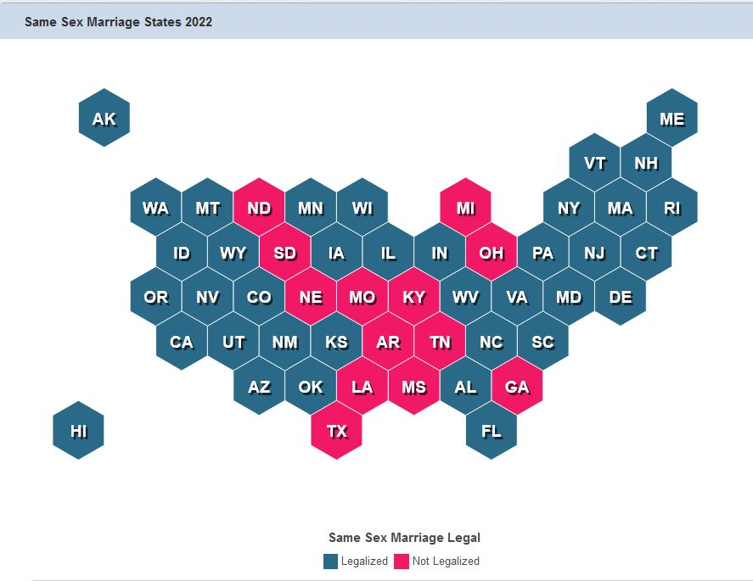
There are 13 States (hmmmm, just the same number of States we were founded with,) who have opposed defining (by Respecting God's definition of marriage as between one man and one woman,) marriage as between two men, two woman, a man or a woman and an animal, or a man or woman to someone under age. These are rights reserved to these States, who (as an example could have 100% of the people who oppose this satanic push by sodomites against God and His Word, Holy Scriptures, the Holy Bible, the Lord Jesus Christ of Nazareth,) to have thrusted upon them a national man-made law requiring them to recognize a satanic law which is an abomination to God!
The fairest nation the world has ever known, the United States of America, thus is becoming completely tyrannical thrusting a law on a group of people (a minority of the nation, but a majority within their State) who refuse to bow the knee to those who opening oppose God, Holy Scripture, the Holy Bible, the Lord Jesus Christ of Nazareth.
I stand with Joshua, if I had a family member that was a Christian, I would declare as did he:

Joshua 24:15 King James Version

15 And if it seem evil unto you to serve the Lord, choose you this day whom ye will serve; whether the gods which your fathers served that were on the other side of the flood, or the gods of the Amorites, in whose land ye dwell: but as for me and my house, we will serve the Lord.

https://www.alemattec.com/Open-Letter-to-Missouri-Republicans-Roy-Blunt-and-Ann-Wagner-Republicans-In-Name-Only,-(R.I.N.0.s)-AND-ALL-OTHER-R.I.N.0.s-in-Congress--concerning-their-support-for-the-'Respect-for-Marriage-Act'.doc

UPDATED: Democrats’ same-sex ‘marriage’ bill advances again in the Senate
https://www.lifesitenews.com/news/us-senate-to-hold-key-procedural-vote-on-same-sex-marriage-bill-today/

Around 60% of Republicans oppose codifying same-sex ‘marriage’ into federal law: poll
https://www.lifesitenews.com/news/around-60-of-republicans-oppose-codifying-same-sex-marriage-into-federal-law-poll/

URGENT: Senate will vote today on Democrats’ radical same-sex ‘marriage’ bill
https://www.lifesitenews.com/news/urgent-senate-will-vote-tomorrow-on-democrats-radical-same-sex-marriage-bill/

Senators Should Stop Playing Games With Religious Liberty and Marriage
https://www.heritage.org/religious-liberty/commentary/senators-should-stop-playing-games-religious-liberty-and-marriage

First Amendment Defense Act Q&A
https://www.lee.senate.gov/first-amendment-defense-act-q-a

Matt Walsh: Republicans who vote for same-sex ‘marriage’ should be ‘exiled from the party’
https://www.lifesitenews.com/news/matt-walsh-republicans-who-vote-for-democrats-same-sex-marriage-bill-should-be-removed-from-the-party/

--
Paul (<:) Jesus first!
www.Alemattec.com

