Barack HUSSEIN Obama, I'll Commemorate Sunday, May 17th, 2015, as ‘International Day Against Homophobia and Transphobia’

http://cnsnews.com/news/article/cnsnewscom-staff/obama-ill-commemorate-sunday-international-day-against-homophobia-and

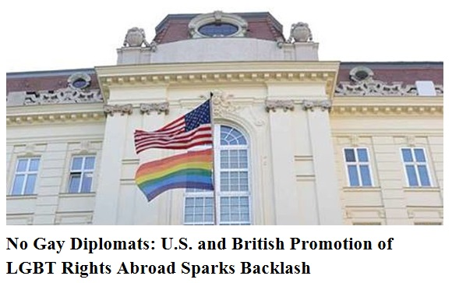
http://www.cnsnews.com/news/article/no-gay-diplomats-us-and-british-promotion-lgbt-rights-abroad-sparks-backlash
Note: You may have to click on File, Print Preview, or File, Page Preview to view image.
www.alemattec.com/Barack HUSSEIN Obama offers plan for U.S. to be global LGBT sex cop.doc
www.alemattec.com/Michael, aka-- Michelle Obama is REALLY a man.htm
--
Paul (<:) Jesus first!
www.Alemattec.com

