I believe the Demoncrats have gone after KEY companies pushing the papacy's United Nations Agenda 21 (Now called Agenda 30.) As the plan is to depopulate the world, they want to make sure any "medicines" or items that prevent illness such as antibiotics, probiotics are compromised, non-functioning.
Agenda 21 (30) third video down:
https://www.alemattec.com/Cowboy-Wisdom-.-.-..htm
2 Using Cell Phones, Smart Meters, 5G--'The papacy Controlled United Nations, UN, Socialist-Communist Political Elites, Governments World Wide Working To Kill Us To Meet The United Nations, Agenda 21--Agenda 30 Goals,' 30MAR22
https://www.alemattec.com/2Using-Cell-Phones,-Smart-Meters,-5G--'The-papacy-Controlled-United-Nations,-UN,-Socialist-Communist-Political-Elites,-Governments-World-Wide-Working-To-Kill-Us-To-Meet-The-United-Nations,-Agenda-21--Agenda-30-Goals,'-.htm
Ninety Percent Purge of All Humanity Required for Papacy controlled United Nations, UN, Sustainable Development --(Agenda 21 now Called 2030 Agenda) Georgia Gildstone
https://www.alemattec.com/Bill-&-Melinda-Gates-Event-201-Global-warming-now-called-climate-change-Chinese-Coronavirus-Green-New-Deal-'pope'-Francis-Jesuits.htm
Probiotics NOW SHIPPING WITHOUT Cold Pack with LIVE BACTERIA . . .
MegaFood Releases First Impact Report Reinforcing Its Commitment to the Planet and People SUPPORT D.E.I.!
https://www.prnewswire.com/news-releases/megafood-releases-first-impact-report-reinforcing-its-commitment-to-the-planet-and-people-301917936.html
My I.B.S. Probiotic has ALWAYS been shipped packed cold, as these have live microorganisms, live cultures, live bacteria. These sat in a hot tractor-trailer for FIVE days.
Tracking Number:
xxx201114117356xxx

Latest Update
Your item was delivered in or at the mailbox at 5:02 pm on June 28, 2024.
Delivered
Delivered, In/At Mailbox
MARYLAND HEIGHTS, MO 63043
June 28, 2024, 5:02 pm
Out for Delivery
MARYLAND HEIGHTS, MO 63043
June 28, 2024, 6:49 am
Arrived at Post Office
MARYLAND HEIGHTS, MO 63043
June 28, 2024, 6:38 am
Arrived at USPS Facility
MARYLAND HEIGHTS, MO 63043
June 28, 2024, 3:36 am
Departed USPS Regional Facility
SAINT LOUIS MO NETWORK DISTRIBUTION CENTER
June 28, 2024, 3:17 am
Arrived at USPS Regional Facility
SAINT LOUIS MO NETWORK DISTRIBUTION CENTER
June 26, 2024, 5:10 pm
Departed USPS Regional Facility
CINCINNATI OH NETWORK DISTRIBUTION CENTER
June 26, 2024, 8:50 am
Arrived at USPS Regional Facility
CINCINNATI OH NETWORK DISTRIBUTION CENTER
June 26, 2024, 12:46 am
Departed USPS Regional Facility
FORT WORTH TX DISTRIBUTION CENTER
June 25, 2024, 7:20 am
Arrived at USPS Regional Origin Facility
FORT WORTH TX DISTRIBUTION CENTER
June 24, 2024, 9:03 pm
USPS in possession of item
GARLAND, TX 75043
June 24, 2024, 11:36 am

Pre-Shipment, USPS Awaiting Item
June 23, 2024
(Look at the bottom below these images . . .)
https://megafood.com/pages/about-our-products-at-megafood

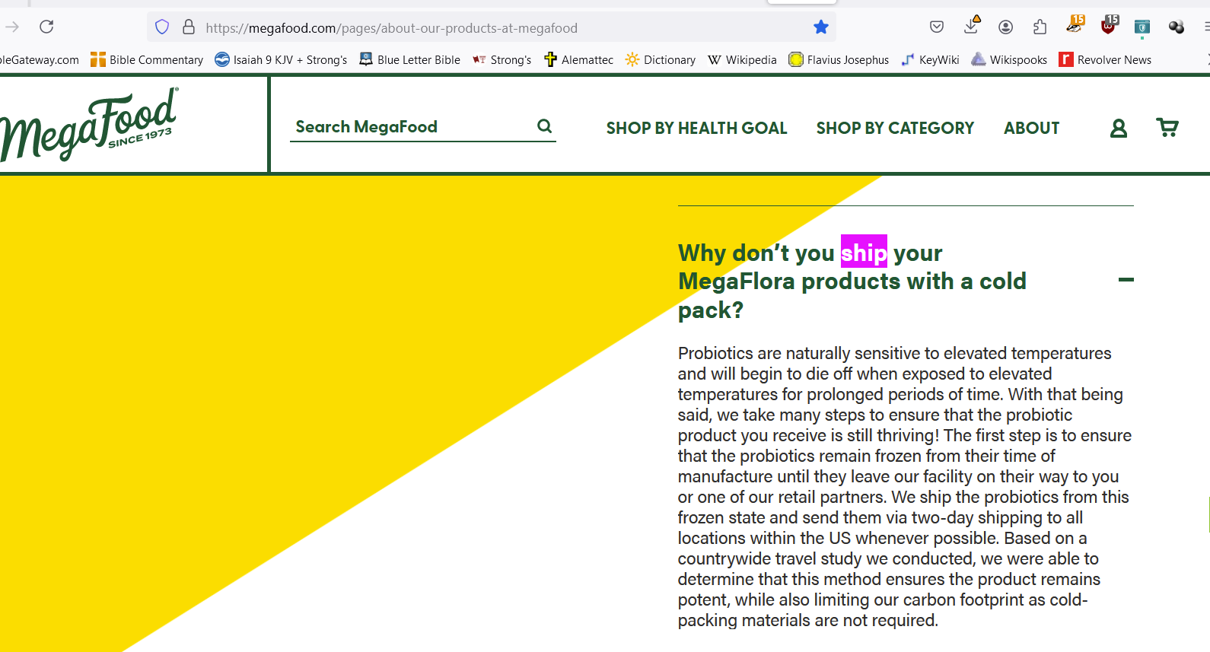


They proudly proclaim that hire twice as many racially or ethnically (deverse groups) than what they claim the State as on average. Message, Christians, white people, need not apply.

Note: *The two images above are from MegaFood's WEB site.

MegaFood MegaFlora Probiotic - Probiotics for Women & Men - Probiotics for Digestive Health & Immune Support - 20 Billion CFU - 14 Strains - Non-GMO - Vegan - Made Without 9 Food Allergens - 90 Caps
https://www.amazon.com/MegaFood-MegaFlora-Probiotic-Supplement-Servings/dp/B001AG4SHE/ref=sr_1_1?crid=1QJZOK9JWGGJF&dib=eyJ2IjoiMSJ9.LcOKU9KDzH27PHaD6Xm4o_KYGLMq53SMEyCh5Ft9Gj5FW1sDgYrLotZrsZdbJ3HcLoGE0B6vxKPRssyTCi2O77cTfA8dZ83bK7bueg5rYvvNH-7gNafY7wXBQwIy7QeIwZaLZ0_C5e_95TTRtPTDRdNRoTfQiT0n5arY3iAdwTjl8Z1PhIznueD3mXU5gRZ0KuzI3-gccWuR4pk9c285t6imF1Fhy0PST7l7mNIItVGBv0lhubJ_803dlWPNmjSCar9CYPtWdDePos5Up0fTOtoizXJ825uh60dZpNDVZaQ.T4y5EY_EnGj5Q9DoZsrkrLw298j-5Jm0i0b1HaacE4o&dib_tag=se&keywords=megafood+megaflora+probiotic&qid=1719614577&sprefix=megafood+megaflora%2Caps%2C92&sr=8-1

https://megafood.com/collections/probiotics/products/megaflora-probiotic
READING THE "FINE PRINT" ON THE BOTTLE AS THE PRINT IS EXTREMELY SMALL (I have a pair of magnifying glasses which has its own light, says, "*Colony forming Units, (CFU) Potency guaranteed until expatriation, when stored as recommended." The bottle cap states in big letters, (STORE IN REFRIGERATOR OR FREEZER TO MAINTAIN POTENCY.)
Sometimes, it's the way you ask the question. Being a contrarian, I assume what most people ask and get the answers "thy system wants you to get." So, I ask specifically what I KNOW instinctively they don't want you to know. Such as:
Sometimes, it's the way you ask the question. Being a contrarian, I assume what most people ask and get the answers "the system wants you to get." So, I ask specifically what I KNOW instinctively they don't want you to know. Such as:
https://www.visbiome.com/blogs/news/the-importance-of-cold-shipping
https://www.healthline.com/nutrition/probiotic-refrigeration#fridge-vs-shelf-stable
Bacteria are hardy creatures for the most part. If a probiotic or microorganism normally lives at refrigerated temperatures and you bring the ambient temperature up above their normal range, most of them will die off. There may be a few (thru mutations) that will live, there is no guarantee they will have the same beneficial probiotic characteristics.
For example, if your probiotic calls for refrigeration but you leave it out on the counter in the middle of the summer, the heat and moisture from humidity can kill some, or all, of the bacteria, even before the expiration date.

What do the experts say?
https://www.goodrx.com/well-being/diet-nutrition/probiotics-need-refrigerated
“Products containing live organisms will need to be refrigerated, as they are sensitive to moisture and heat,” Greene said. “However, if a product uses freeze-dried organisms, they often do not require refrigeration.”
Be sure to read the label on the bottle before purchasing the supplement, as it will state whether it requires refrigeration or if it’s shelf-stable. (Carol, the label says refrigerate).
“It’s important to note that if your probiotic says it should be refrigerated on the bottle, but you do not see it stored that way in the store, or if it is shipped to you without ice, you should assume that the potency has drastically declined,” Greene said. Carol, they have a sticker on top of the bottles cap that says, "STORE IN REFRIGERATOR OR FREEZER"
Another thing to watch out for on the label? The number of CFUs listed on the probiotic bottle. CFU stands for “colony-forming unit,” which is how manufacturers quantify the number of live bacteria that make up one serving of probiotics. CFUs are the same as "live cultures."
“When looking for a probiotic, check to make sure that the amount of CFUs are guaranteed through expiration,” Greene said, advising to ditch any bottles that say “[#] CFU at the time of manufacture.”
How do probiotics stay alive in supplements?
https://www.vitacost.com/blog/shelf-stable-vs-refrigerated-probiotics/
Whether refrigerated or freeze-dried, microbes in probiotic supplements don’t grow or multiply until they reach your gut, where they encounter the temperature, acidity, water, and nutrients they need to become active again.
But before they get to your gut, dormant microbes can be affected by transportation and storage conditions. Refrigerated probiotics that get too warm during shipping may die off, and shelf-stable probiotics can become less effective when exposed to heat or humidity. Manufacturers may add extra probiotic organisms, known as “overage,” to their products to compensate for potential decreases in viability.
While these practices can help probiotics stay alive in supplements, the microbes don’t always survive the high acidity in your stomach or the digestive enzymes in your small intestine. Microbes that reach your colon must compete with the rest of your microbiome for nutrients and living space.
That doesn’t mean probiotic supplements are useless. Research shows that probiotic microbes can have benefits even if they only stick around in your gut for a short time.
Examiner discusses what conditions can be like inside an 18-wheeler's trailer without AC
https://www.kvue.com/article/news/local/texas/conditions-inside-a-hot-18-wheelers-trailer/269-9497a1a4-73df-4938-a6f9-d7f7b25cb8d6
"On a typical Texas summer, it's 100 degrees out, it’s going to shoot that box temperature up 130, maybe 150 possibly," said Kibby.

Interior and Exterior Temperatures of a Parked Tractor-Trailer
https://www.researchgate.net/figure/Interior-and-Exterior-Temperatures-of-a-Parked-Tractor-Trailer_fig1_283269423
(Note: This is a study done on pallets.)
In a previous study [2] , the temperature inside a truck container could easily reach 150 F. This article reports the effect of high temperatures . . .
Think it’s hot outside? Here’s how much hotter it can get inside your truck.
https://cdllife.com/2020/think-its-hot-outside-heres-how-much-hotter-it-can-get-inside-your-truck/

Are Hot Trucks Threatening the Health and Productivity of Your Workers?
https://portacool.com/are-hot-trucks-threatening-the-health-and-productivity-of-your-workers/
With shipping trucks often reaching temperatures as high as 130°, the number of errors will rise steeply. This can result in the contents of a shipping truck becoming damaged in transit due to errors in the steps taken to secure these items when they are loaded, costing your business a lot of money.
I'm a former Operations Manager for both trucking and a Cargo Airline. I personally know about how hot it can be inside a tractor-trailor (and that's with the rear door opened!) It's like a furnace!
--
Paul (<:) Jesus first!
www.Alemattec.com

