Black Lives Matter mobilizes in Baton Rouge for protests, passes on flood relief
http://www.washingtontimes.com/news/2016/aug/21/black-lives-matter-takes-heat-louisiana-flood-reli/

The Ford Foundation recently committed to working with other philanthropies to funnel $100 million to the Movement for Black Lives.

Who Is Funding Black Lives Matter
http://fortune.com/2016/08/08/funding-black-lives-matter-ford/
More than 50 organizations have already registered their support, but one, in particular, stands out. The Ford Foundation added their voice to the growing chorus of supporters, in the strongest possible terms.
But the foundation is also planning on studying and underwriting what it calls a “new and dynamic form of social justice leadership and infrastructure,” by investing in the Black-Led Movement Fund, (BLMF) a pooled donor fund designed to support the work of the Movement for Black Lives (M4BL), and led by Borealis Philanthropy.

Black Lives Matter Keeps Getting More Radical — Will the Media Care?
http://www.nationalreview.com/article/438726/

Black Lives Matter is an instrument not of justice and reconciliation but rather of violence and revolution. It’s shot through with its own form of racism — anti-Semitism — and with authoritarian demands that would not only strip Americans of their constitutional rights but bankrupt our nation and render it vulnerable to its enemies abroad. Doubt me? Read the organization’s own words.
On Monday, Black Lives Matter joined with dozens of radical civil-rights groups to issue an official “platform,” and the document is nothing less than an extraordinary grab bag of anti-American and fundamentally Marxist demands. It declares, for example, that “America is an empire that uses war to expand territory and power,” and then advocates vast cuts in the military budget and the immediate end to all American military engagements. Inexplicably, it also attacks Israel, calling it an “apartheid state” and declaring it guilty of “genocide” against Palestinians. According to BLM, it’s important for black Americans to tie themselves to “liberation movements around the world.” If you care about the Constitution or the economy here at home, Black Lives Matter does not care about you. It would end “the privatization of education” (except at “historically black colleges and universities”), depriving students of First Amendment rights of free speech and free association and depriving parents of the fundamental natural right to raise and educate their own children. At the same time, it demands free tuition and open admission for all black people at every public university in the United States and demands free “housing, transportation, childcare, healthcare, and food” for all students.
Black Lives Matter: Radicals Using Moderates to Help Tear America Apart
http://www.nationalreview.com/article/437677/black-lives-matter-radical-divisive

In Dallas, a black terrorist opens fire on police, killing five in the worst police massacre since 9/11. In Tennessee, a black man who claimed to be motivated by “police violence against African Americans” opened fire on a highway, killing a woman and injuring three others — including a police officer. In Missouri, a black motorist ambushed a white police officer after a traffic stop — shooting the officer in the neck and leaving him “fighting for his life.” Also in Missouri, a young black man threw a planter through the front door of an off-duty police officer’s home and advanced into the house while the officer’s wife, mother-in-law, and young children tried to escape through a back window. The officer opened fire and killed the intruder. He apparently targeted the home after an online argument over Black Lives Matter. In Minnesota, Black Lives Matter protesters attacked police with “rocks, bottles, and other items,” injuring 21 — including an officer who suffered a broken vertebra “after a concrete block was dropped on his head.” This is a partial list, not counting lawless protests that blocked interstates, bridges, and other roads across the United States, creating a number of inherently dangerous confrontations between protesters, motorists, and the police. And — again — it’s a partial list from the last week only. Extend the time horizon and the killings increase, the violent protests increase, and the incidents of chants calling for violence multiply.
And consider the Black Lives Matter organization itself. Its website is a grab-bag collection of unthinking radicalism and cultural Marxism. Want to know what Black Lives Matter thinks about the nuclear family? Consider its statement on so-called Black Villages: We are committed to disrupting the Western-prescribed nuclear family structure requirement by supporting each other as extended families and “villages” that collectively care for one another, and especially “our” children to the degree that mothers, parents and children are comfortable. Do you want a nuanced and careful response to the problem of high crime rates in black communities and the problem of mass incarceration? Don’t go to Black Lives Matter — It believes that “2.8 million Black people are locked in cages in this country is state violence.” Then there’s this incredible statement about gender and sexuality: Black queer and trans folks bear a unique burden from a hetero-patriarchal society that disposes of us like garbage and simultaneously fetishizes us and profits off of us, and that is state violence. Or there’s this statement about black people with disabilities: Black folks living with disabilities and different abilities bear the burden of state sponsored Darwinian experiments that attempt to squeeze us into boxes of normality defined by white supremacy, and that is state violence.

America Is Driving toward the Abyss, and It’s Time We Hit the Brakes
http://www.nationalreview.com/article/437625/dallas-police-shooting-demands-calm-debate?target=topic&tid=6342

Black Lives Matter . . .
Gender, Racial, and Ethnic Justice

https://www.fordfoundation.org/work/challenging-inequality/our-approach/gender-racial-and-ethnic-justice/
Note: Notice the large Black Lives Matter poster . . .

White men 15% of the total “Program Officers” who decide who will get millions upon millions of dollars of grants . . .
https://www.fordfoundation.org/people/grant-makers/

Note: Images on their WEB site: Notice one white male (possibly in blue shirt) voter on the top of the page. . . replaced on the photo at the bottom of the page with a Muslim woman.
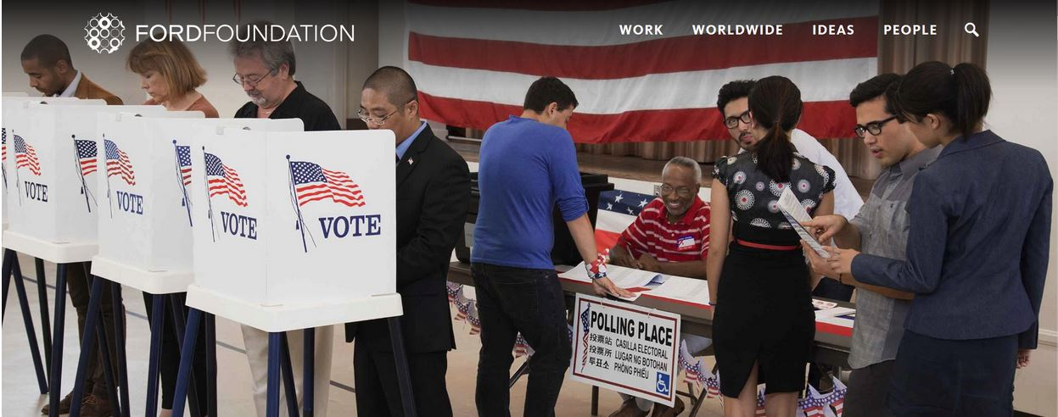
On the bottom of the page, no white male voters . . . replaced by a Muslim woman.
https://www.fordfoundation.org/ideas/equals-change-blog/posts/how-to-encourage-better-and-more-meaningful-political-participation-in-the-us/

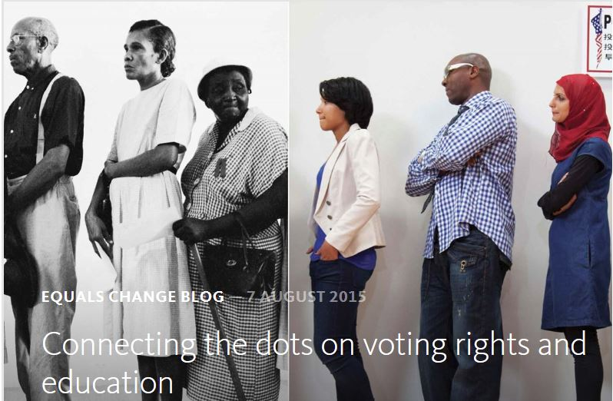

https://en.wikipedia.org/wiki/Ford_Foundation#Support_of_the_African_Gender_Institute
The Ford Foundation is a New York headquartered, globally oriented private foundation with the mission of advancing human welfare. In 1968, the foundation began disbursing US$12 million to persuade law schools to make "law school clinics" part of their curriculum. Clinics were intended to give practical experience in law practice while providing pro bono representation to the poor. Many people, however, charge that the clinics have been used instead by professors to engage in political activism. Critics cite the financial involvement of the foundation as the turning point when these clinics began to change from giving practical experience to engaging in advocacy.
In 1994, American author and former philosophy professor Christina Hoff Sommers alleged that the Ford Foundation funded "gender feminism", ideology that abandoned the feminist quest for equity in favor of a gender war against men. Spanish judge Francisco Serrano Castro (es) made similar claims in his 2012 book The Dictatorship of Gender.
In 2003, the foundation was critiqued by U.S. news service Jewish Telegraphic Agency, among others, for supporting Palestinian nongovernmental organizations that that were accused of promoting antisemitism at the 2001 World Conference Against Racism. Under pressure by several members of Congress, chief among them Rep. Jerrold Nadler, the foundation apologized and then prohibited the promotion of "violence, terrorism, bigotry or the destruction of any state" among its grantees. This move itself sparked protest among university provosts and various non-profit groups on free speech issues.

This criticism came to light after the 2001 Durban Conference, where some nongovernmental organizations funded by the Ford Foundation backed resolutions equating Israeli policies as apartheid . . .

Current President of the Ford Foundation, Darren Walker:

Darren Walker is a nonprofit executive who serves as president of the Ford Foundation. Earlier in his career, Walker worked as a lawyer and as an investment banker.
Walker is a fellow of the Institute for Urban Design, a member of the Council on Foreign Relations, and a board member of the Arcus Foundation, Rockefeller Philanthropy Advisors, Friends of the High Line, and the Foundation for Art and Preservation in Embassies. He has been a teacher of housing, law and urban development at the New York University School of Law and the Robert F. Wagner Graduate School of Public Service. He is co-chair of the New York Public Library Council. He is board of directors vice-chairman at the New York City Ballet.
Mr. Walker — who now lives in New York with his partner David Beitzel, is an art dealer in Manhattan.
https://www.philanthropy.com/article/Ford-Foundation-Names-Darren/154553

https://en.wikipedia.org/wiki/Ford_Foundation

"Darren Walker Named New President of the Ford Foundation".
http://www.thehabarinetwork.com/darren-walker-named-new-president-of-the-ford-foundation

What Money Can Buy

Darren Walker and the Ford Foundation set out to conquer inequality.
http://www.newyorker.com/magazine/2016/01/04/what-money-can-buy-profiles-larissa-macfarquhar
He wanted to belong to things, he was a joiner, but he didn’t know anybody, so he responded to every flyer he saw. He signed up for the Liberal Arts Council; he joined the Black Student Alliance; he practically lived at the Student Union. He worked at the student-run art gallery, planning shows. He wanted to be part of everything, and he had nothing to lose. He was elected chair of the Student Union and was the first black Abbot of the Friar Society, https://en.wikipedia.org/wiki/Friar_Society, and he was in the yearbook so much they thought about calling it “The Cactus Yearbook, featuring Darren Walker.”

Note: Rituals and Traditions
http://www.friarsociety.org/history/beginnings
Since the early months of the Society in 1911, the traditions and meetings of the society, and, most important, the process by which it selects its membership, have been under a cloak of secrecy known only to Society members.

He (Darren Walker) never came out as gay explicitly, but he never felt that this was a problem. He sensed that his family had always known that he was different and accepted him as such, even though they never talked about it. At college, he felt that people understood that he was gay, and he knew that there had always been a place in Southern culture for gay men, even if they weren’t called that. Anyhow, when it came to the barriers he had to leap over just to get out of bed in the morning at the University of Texas, being gay was nothing compared to being black, or being from the kind of place he was from. There were middle-class white people who were gay, but there were no middle-class white people who were black, or poor. No barrier was too high for him, though, because he believed that he could succeed, and when people tried to help him he didn’t feel insulted: he was grateful, he wanted to learn.
Darren Walker is a 1982 graduate of The University of Texas at Austin, and a 1986 graduate of its School of Law. He has taught housing, law and urban development at the New York University School of Law and Robert F. Wagner Graduate School of Public Service, and is a fellow of the Institute for Urban Design.
Deeply engaged in community affairs and widely respected for his gifts of both substance and style, he is a member of the boards of the Arcus Foundation, Rockefeller Philanthropy Advisors, Friends of the High Line, the New York City Ballet, and the Foundation for Art and Preservation in Embassies. He is also a member of the Council on Foreign Relations.
The Arcus Foundation is a charitable foundation focused on issues related to LGBT rights, social justice and conservation. The foundation's stated mission is "to ensure that LGBT people and our fellow apes thrive in a world where social and environmental justice are a reality."
The Arcus Foundation is the top LGBT-specific grant-making organization in the United States. The foundation was founded by Jon Stryker, heir to the Stryker Corporation medical supply company fortune. The foundation has offices in New York, New York, and Cambridge, England.
https://en.wikipedia.org/wiki/Arcus_Foundation
LGBT rights
The Arcus Foundation is a major supporter of LGBT advocacy efforts. The foundation has given money to oppose religious liberty exemptions, including a 2014 grant of $100,000 to the American Civil Liberties Foundation supporting “communications strategies to convince conservative Americans that religious exemptions are 'un-American'" and a $600,000 grant to the ACLU in 2013 to support the ACLU's Campaign to End the Use of Religion to Discriminate. In 2013, the Arcus Foundation launched a new Social Justice Initiative which has placed a heavy emphasis on reaching out to faith communities around the world to build cultural acceptance for LGBT people.
In January 2011, the foundation made a $23 million grant to establish the Arcus Center for Social Justice Leadership at Kalamazoo College in Kalamazoo, Michigan.
In 2014, Arcus awarded $75,000 to the Washington, DC-based Faithful America to “promote greater media visibility for Christians who denounce the abuse of religious-freedom arguments to oppose full equality” for LGBT people. Arcus has also awarded at least $200,000 to a coalition of groups seeking to "counter the narrative of the Catholic Church" and "to support pro-LGBT faith advocates to influence and counter the narrative of the Catholic Church and its ultra-conservative affiliates."
Note: Faithful America, an online interfaith community, www.alemattec.com/Interfaith . . . Danger, Danger, Will Robinson . . . .doc, based in Washington.
In April 2015, the Catholic News Agency (CNA) published an article disclosing that the Religion News Service (RNS), a U.S. news agency focused on religion, ethics, spirituality and moral issues, had received a grant of $120,000 from the Arcus Foundation. The grant's stated intent was “to recruit and equip LGBT supportive leaders and advocates to counter rejection and antagonism within traditionally conservative Christian churches.” The CNA story questioned whether the grant had biased RNS's coverage of traditional religion, specifically citing an RNS article on Cardinal Raymond Burke. In response to the CNA report, RNS's editor-in-chief denied that the Arcus grant had any influence over editorial decisions at RNS.
In December 2015, the Arcus Foundation announced $15 million in funding to boost the transgender movement in the U.S. and globally.
At present, the foundation is among the world’s largest private philanthropies, with more than US$11 billion in assets and over $500 million in annual giving. More information can be found at the organization’s website, www.fordfoundation.org.
TIME 100 Leaders

Darren Walker
By Elton John
http://time.com/4301843/darren-walker-2016-time-100/
Darren Walker An expert on an array of social justice issues, Darren Walker is president of the Ford Foundation, the nation's second largest philanthropy.
http://www.huffingtonpost.com/author/darren-walker
He also oversaw the foundation’s regional programming in four offices based in Africa and the Middle East.
https://www.fordfoundation.org/regions/middle-east-and-north-africa/
https://www.fordfoundation.org/ideas/equals-change-blog/posts/putting-ford-forward-into-action/
More than half of them are based or work in the Global South, while others work on domestic issues in the United States. More than half are led by women and people of color.
The Movement for Black Lives . . .
https://policy.m4bl.org/platform/
In response to the sustained and increasingly visible violence against Black communities in the U.S. and globally, a collective of more than 50 organizations representing thousands of Black people from across the country have come together with renewed energy and purpose to articulate a common vision and agenda. We are a collective that centers and is rooted in Black communities, but we recognize we have a shared struggle with all oppressed people; collective liberation will be a product of all of our work.
We believe in elevating the experiences and leadership of the most marginalized Black people, including but not limited to those who are women, queer, trans, femmes, gender nonconforming, Muslim, formerly and currently incarcerated, cash poor and working class, differently-abled, undocumented, and immigrant. We are intentional about amplifying the particular experience of state and gendered violence that Black queer, trans, gender nonconforming, women and intersex people face. There can be no liberation for all Black people if we do not center and fight for those who have been marginalized. It is our hope that by working together to create and amplify a shared agenda, we can continue to move towards a world in which the full humanity and dignity of all people is recognized.
While this platform is focused on domestic policies, we know that patriarchy, exploitative capitalism, militarism, and white supremacy know no borders. We stand in solidarity with our international family against the ravages of global capitalism and anti-Black racism, human-made climate change, war, and exploitation. We also stand with descendants of African people all over the world in an ongoing call and struggle for reparations for the historic and continuing harms of colonialism and slavery. We also recognize and honor the rights and struggle of our Indigenous family for land and self-determination.
We have created this platform to articulate and support the ambitions and work of Black people. We also seek to intervene in the current political climate and assert a clear vision, particularly for those who claim to be our allies, of the world we want them to help us create. We reject false solutions and believe we can achieve a complete transformation of the current systems, which place profit over people and make it impossible for many of us to breathe.
Together, we demand an end to the wars against Black people. We demand that the government repair the harms that have been done to Black communities in the form of reparations and targeted long-term investments. We also demand a defunding of the systems and institutions that criminalize and cage us. This document articulates our vision of a fundamentally different world. However, we recognize the need to include policies that address the immediate suffering of Black people. These policies, while less transformational, are necessary to address the current material conditions of our people and will better equip us to win the world we demand and deserve.
Who’s the "Puppet Master" behind the scenes, pulling the strings . . . Socialist/Communist, Jew (who also hates the Jews) multibillionaire, George Soros, papal Knight, Illuminati, under the Jesuits . . . under the "pope" of Rome, Francis I . . .

The Bizarre Media Blackout Of Hacked George Soros Documents
http://www.investors.com/politics/editorials/the-bizarre-media-blackout-of-hacked-george-soros-documents/
Illumaniti, Papal Knight George Soros funded #BlackLivesMatter movement . . .

As we noted in this space on Monday, the leaked documents show how Soros' far-flung international organizations attempted to manipulate Europe's 2014 elections. The "List of European Elections 2014 Projects" details over 90 Soros efforts he had under way that year.
The documents reveal that Soros has poured nearly $4 million into anti-Israel groups, with a goal of "challenging Israel's racist and anti-democratic policies."
Here at home, they show that Soros proposed paying the Center for American Politics $200,000 to conduct a smear campaign against conservative activists.
More recently, an October 2015 document came to light showing that Soros' Open Society U.S. Programs had donated $650,000 to "invest in technical assistance and support for the groups at the core of the burgeoning #BlackLivesMatter movement." Since then, several BLM protests have turned violent.
Another details how Soros tried to use his clout to sway Supreme Court justices into approving President Obama's unilateral effort to rewrite immigration law. "Grantees are seeking to influence the Justices (primarily via a sophisticated amicus briefs and media strategy) in hopes of securing a favorable ruling in U.S. v Texas," the memo, dug up by the Daily Caller, states:
Anyone with this much power and influence demands close media scrutiny, particularly when he has extremely close ties to the would-be next president of the United States.
***MUCH MORE ON THIS LATER***

www.alemattec.com/Stupid white men, stupid fathers, LGBT, i.e. -- sodomites. Also, blacks, Jews, Mexicans, Islam, etc . . . and lies by the Obama Administration concerning race . . . .doc

www.alemattec.com/Honda, woman in yellow. . .htm

--
Paul (<:) Jesus first!
www.Alemattec.com

