November 9, 2022

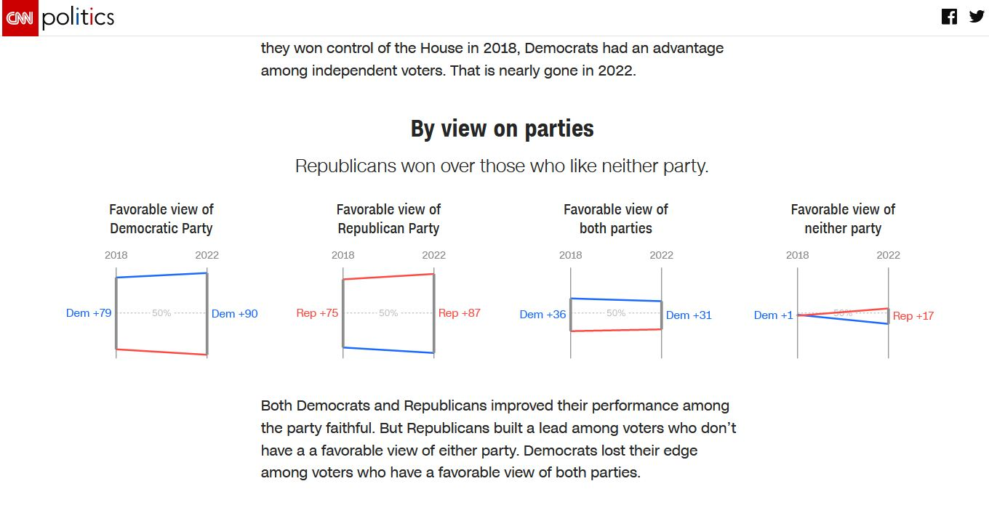

Another Stolen Election
November 9, 2022 | Categories: Articles & Columns | Tags: | Print This Article
Another Stolen Election
Paul Craig Roberts
https://www.paulcraigroberts.org/2022/11/09/another-stolen-election/
This time it is CNN’s own report on its own exit polls that indicates a stolen election.
Today November 9, 2022, updated at 10:49 AM EST, CNN reporters Zachary B. Wolf and Curt Merrill remarked that the widely expected red wave did not materialize and then went on to present data that is inconsistent with the closeness of the voting.
The reporters compare the exit polls from the 2018 elections with those of the 2022 elections. The comparisons show that the Democrats lost support in Tuesday’s elections among women, moderates, youth, people of color, urban voters, college graduates, and independents.

https://www.cnn.com/interactive/2022/politics/exit-polls-2022-midterm-2018-shift/

The Democrats’ support among women declined from 19 points favorable to Democrats to only 8 points. Republican support among men rose from 4 points over Democrats to 14 points.
By age, the preference for Democrats over Republicans for 18-29 years of age declined from 35 points to 28 and for 30-44 years of age from 19 points to 4. Republican support over Democrats rose from 1 to 10 points for those 45-64 years of age and from 2 to 12 points for those 65 and older.
White men’s preference for Republicans increased from 21 to 28 points. White women moved from a 50-50 split to an 8 point preference for Republicans. Black women’s preference for Democrats declined from 85 points to 78. Black men’s preference for Democrats declined from 76 points to 65. Latina women’s preference for democrats fell from 47 points to 33; and Latino men’s preference for Democrats fell from 29 points to 8.

Urban voters preference for Democrats declined from 33 points over Republicans to 17 points. Suburban and Rural voters preferences for Republicans rose by 6 points and 15 points.
Democrats also lost support among white and black college graduates. Among white votes without college degrees the preference for Republicans rose by 10 points.
Among moderates, the preference for Democrats eroded from 26 points to 15. Among conservatives the Republican advantage rose from 67 points t 83. Among liberals there was essentially no change.
The CNN exit polls show substantial erosion of the Democrat voting base since the 2018 election. How can such substantial erosion be consistent with the lack of any significant Republican gain on Tuesday?
The outcome of Tuesday’s election is made even more difficult to comprehend by CNN’s reporters when they report:
“Back in 2018, 37% of voters said they were Democrats, compared with 33% who said they were Republicans and 30% who said they were independents. In 2022, it was Republicans who have the edge. When they won control of the House in 2018, Democrats had an advantage among independent voters. That is nearly gone in 2022.
“Both Democrats and Republicans improved their performance among the party faithful. But Republicans built a lead among voters who don’t have a a favorable view of either party. Democrats lost their edge among voters who have a favorable view of both parties.”
There are many other indications that indicate that much is amiss in the vote count. Polls show that Biden suffers an approval rate of only 36% and that a large majority of Americans do not want Biden to run for reelection in two years. How is this preference consistent with the vote count of Tuesday’s election?
Consider also that the party in power loses representation in midterm elections, but despite the substantial turn away from Democrats revealed by CNN, this normal result did not occur on Tuesday.

Consider also public dissatisfaction with: record crime, record inflation with high food and gasoline prices, rising interest rates and falling home values, massive illegal immigration, forced indoctrination of school children with transgender theory and critical race theory, Biden’s Covid vaccination mandates that caused health injuries, deaths, and destroyed careers, Biden’s Covid lockdowns that destroyed businesses, jobs, supply chains and raised prices, Biden’s “Russian” sanctions that disrupted energy supply and raised the price of everything. Considering all this dissatisfaction, how did Fetterman, a person impaired by a stroke and afflicted with problems speaking who wants to release criminals from prison, win a seat in the US Senate from Pennsylvania? How did the same Georgia voter who returned Republican Gov. Kemp to office vote against black Republican and football star Herschel Walker in favor of black Democrat Warnock, who hates Trump and white people, for the US Senate?

Finally, consider the Diebold voting machines that malfunctioned in New Jersey, Arizona, and Texas, and Gateway Pundit’s report that in Detroit, Michigan, ballots were being delivered through the back door in the early hours of Wednesday morning long after the legal deadline.
Now, ask yourself, what is worse, a stolen US election or an American electorate so insouciant (Insouciant: Lighthearted unconcern) and out to lunch that they would keep a political party in office that is leading us into war with Russia and China, that hates white people and persecutes them, that has politicized the FBI and Department of Justice turning them into Gestapo agencies serving Democrat power, that fervently believes that parents are bad for children and should have no say in their education (brainwashing), that is demonizing normality and normalizing perversity, that . . . I could go on and on. Here was a chance for voters to register their dissent, and according to the vote results they failed to do so. If the vote count is honest, then the conclusion is that we must write off the American people as beings too stupid to survive as a free people.
This is why I much prefer to believe that the election was again stolen.

What can be done about stolen elections? Nothing. Especially when a previously stolen election has left Democrats in control of the executive branch. The executive branch is the police branch. It is not going to enforce election or any law against itself.
Note: This is NOT why " . . . I much prefer to believe that the election was again stolen." My take on this . . . the 2020 Mid-term Elections WERE STOLEN, plain and simple. Common sense, reason, and ALL the data plainly show it to be so, even here by CNN (the Communist News Network). The only one's denying it are, "Liars, damned liars, and those that cheat with the statistics". (The majority of Democrats, all of their leaders almost to the man (woman,) the fake news media, the politicized Tech. companies, those paid by the Vatican/Soros, communists, and brainwashed "useful idiots").

--
Paul (<:) Jesus first!
www.Alemattec.com

