Joshua should know, he was a General of the Nation of Israel's Army. He was a young man, and was Moses' Minister.
Exodus 24:12-14 King James Version
12 And the Lord said unto Moses, Come up to me into the mount, and be there: and I will give thee tables of stone, and a law, and commandments which I have written; that thou mayest teach them.
13 And Moses rose up, and his minister Joshua: and Moses went up into the mount of God.
14 And he said unto the elders, Tarry ye here for us, until we come again unto you: and, behold, Aaron and Hur are with you: if any man have any matters to do, let him come unto them.
Note: In order to go up higher on the mount. Joshua, and he only, was to go up higher with Moses upon the mount, though not to the top of the mount, at least not into the cloud upon it, as Moses did. Joshua was his minister or personal servant, and waited upon Moses wherever he went, and was to be his successor. Therefore for Joshua's encouragement, and to qualify him the better for it, he was indulged with a sight and knowledge of things others were not. Joshua did not know anything of the idolatry of the golden calf, Exodus 32:17 it appears that he was on some part of the mount all the forty days and forty nights Moses was higher up with God. If it should be asked whether Joshua fasted all that time, or, if he did not, how he was provided with food and drink? There simply is no necessity to suppose that he fasted all that time. We should know easily how Joshua was supplied, for the manna fell round about the mountain, of which he might gather and eat day by day. Additionally, there was a brook which descended out of the mount, from whence he might have water, Deuteronomy 9:15-21.
www.alemattec.com/Fear not, the Mighty God, the Lord of Hosts, the Lord Jesus Christ of Nazareth . . . .doc

Joshua of the Bible
https://www.chabad.org/library/article_cdo/aid/111849/jewish/Joshua-of-the-Bible.htm#Joshuas
Immediately after crossing the Jordan, Joshua sent two spies, Caleb and Pinchas, to the city of Jericho, the Jews’ first point of attack. Disguised, the spies made their way to an inn owned by a woman, a harlot named Rahab. When the spies were discovered and soldiers were dispatched to capture them, Rahab saved their lives. She asked them that just as she had saved their lives , so should they save hers and her family’s. She declared her faith in the Jewish God, and revealed that the people of Canaan were petrified of the Jews and that they knew the Jews would overcome them. The spies gave Rahab their word and snuck out of the city.
Later, after the Jews kept their word and saved Rahab and her family, she converted to Judaism. She was a very special woman, and Jewish Sages teach that God seeks out righteous people from the nations and draws them to His faith, citing Rahab and Jethro as examples. So sincere and holy was she, Joshua eventually married her. Eight prophets, including Jeremiah, descended from their union.
https://www.chabad.org/library/article_cdo/aid/111849/jewish/Joshua-of-the-Bible.htm

Model Mentoring: Moses and Joshua
https://preachitteachit.org/devotional/model-mentoring-moses-and-joshua/

Exodus 14:13-14 King James Version
13 And Moses said unto the people, Fear ye not, stand still, and see the salvation of the Lord, which he will shew to you to day: for the Egyptians whom ye have seen to day, ye shall see them again no more for ever.
14 The Lord shall fight for you, and ye shall hold your peace.

Exodus 15:2-4 King James Version
1 Then sang Moses and the children of Israel this song unto the Lord, and spake, saying, I will sing unto the Lord, for he hath triumphed gloriously: the horse and his rider hath he thrown into the sea.
2 The Lord is my strength and song, and he is become my salvation: he is my God, and I will prepare him an habitation; my father's God, and I will exalt him.
3 The Lord is a man of war: the Lord is his name.
4 Pharaoh's chariots and his host hath he cast into the sea: his chosen captains also are drowned in the Red sea.
Deuteronomy 31:1-8 King James Version
1 And Moses went and spake these words unto all Israel.
2 And he said unto them, I am an hundred and twenty years old this day; I can no more go out and come in: also the Lord hath said unto me, Thou shalt not go over this Jordan.
3 The Lord thy God, he will go over before thee, and he will destroy these nations from before thee, and thou shalt possess them: and Joshua, he shall go over before thee, as the Lord hath said.
4 And the Lord shall do unto them as he did to Sihon and to Og, kings of the Amorites, and unto the land of them, whom he destroyed.
5 And the Lord shall give them up before your face, that ye may do unto them according unto all the commandments which I have commanded you.
6 Be strong and of a good courage, fear not, nor be afraid of them: for the Lord thy God, he it is that doth go with thee; he will not fail thee, nor forsake thee.
7 And Moses called unto Joshua, and said unto him in the sight of all Israel, Be strong and of a good courage: for thou must go with this people unto the land which the Lord hath sworn unto their fathers to give them; and thou shalt cause them to inherit it.
8 And the Lord, he it is that doth go before thee; he will be with thee, he will not fail thee, neither forsake thee: fear not, neither be dismayed.

Joshua 24:1-15 King James Version
1 And Joshua gathered all the tribes of Israel to Shechem, and called for the elders of Israel, and for their heads, and for their judges, and for their officers; and they presented themselves before God.
2 And Joshua said unto all the people, Thus saith the Lord God of Israel, Your fathers dwelt on the other side of the flood in old time, even Terah, the father of Abraham, and the father of Nachor: and they served other gods.
3 And I took your father Abraham from the other side of the flood, and led him throughout all the land of Canaan, and multiplied his seed, and gave him Isaac.
4 And I gave unto Isaac Jacob and Esau: and I gave unto Esau mount Seir, to possess it; but Jacob and his children went down into Egypt.
5 I sent Moses also and Aaron, and I plagued Egypt, according to that which I did among them: and afterward I brought you out.
6 And I brought your fathers out of Egypt: and ye came unto the sea; and the Egyptians pursued after your fathers with chariots and horsemen unto the Red sea.
7 And when they cried unto the Lord, he put darkness between you and the Egyptians, and brought the sea upon them, and covered them; and your eyes have seen what I have done in Egypt: and ye dwelt in the wilderness a long season.
8 And I brought you into the land of the Amorites, which dwelt on the other side Jordan; and they fought with you: and I gave them into your hand, that ye might possess their land; and I destroyed them from before you.
9 Then Balak the son of Zippor, king of Moab, arose and warred against Israel, and sent and called Balaam the son of Beor to curse you:
10 But I would not hearken unto Balaam; therefore he blessed you still: so I delivered you out of his hand.
11 And you went over Jordan, and came unto Jericho: and the men of Jericho fought against you, the Amorites, and the Perizzites, and the Canaanites, and the Hittites, and the Girgashites, the Hivites, and the Jebusites; and I delivered them into your hand.
12 And I sent the hornet before you, which drave them out from before you, even the two kings of the Amorites; but not with thy sword, nor with thy bow.
13 And I have given you a land for which ye did not labour, and cities which ye built not, and ye dwell in them; of the vineyards and oliveyards which ye planted not do ye eat.
14 Now therefore fear the Lord, and serve him in sincerity and in truth: and put away the gods which your fathers served on the other side of the flood, and in Egypt; and serve ye the Lord.
15 And if it seem evil unto you to serve the Lord, choose you this day whom ye will serve; whether the gods which your fathers served that were on the other side of the flood, or the gods of the Amorites, in whose land ye dwell: but as for me and my house, we will serve the Lord.

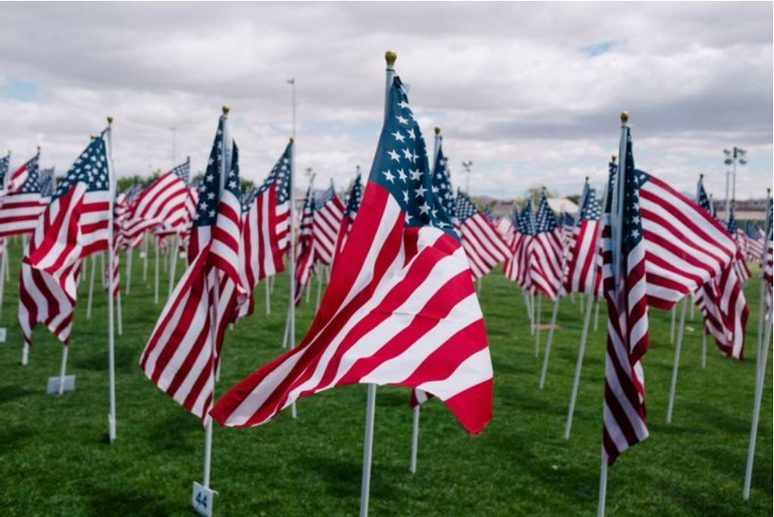
I’M SURE GLAD OUR US MILITARY WERE AND STILL ARE EXTREMELY
#STRONG AND #COURTEOUS sic #COURAGEOUS
This is my command—be strong and courageous! Do not be afraid or discouraged. For the LORD your God is with you wherever you go.
Joshua 1:9
#VeteransDay2021
#GodBlessAmerica
Respectfully,
Skip
--
Paul (<:) Jesus first!
www.Alemattec.com

