The difference between Communism, Capitalism, and Socialism

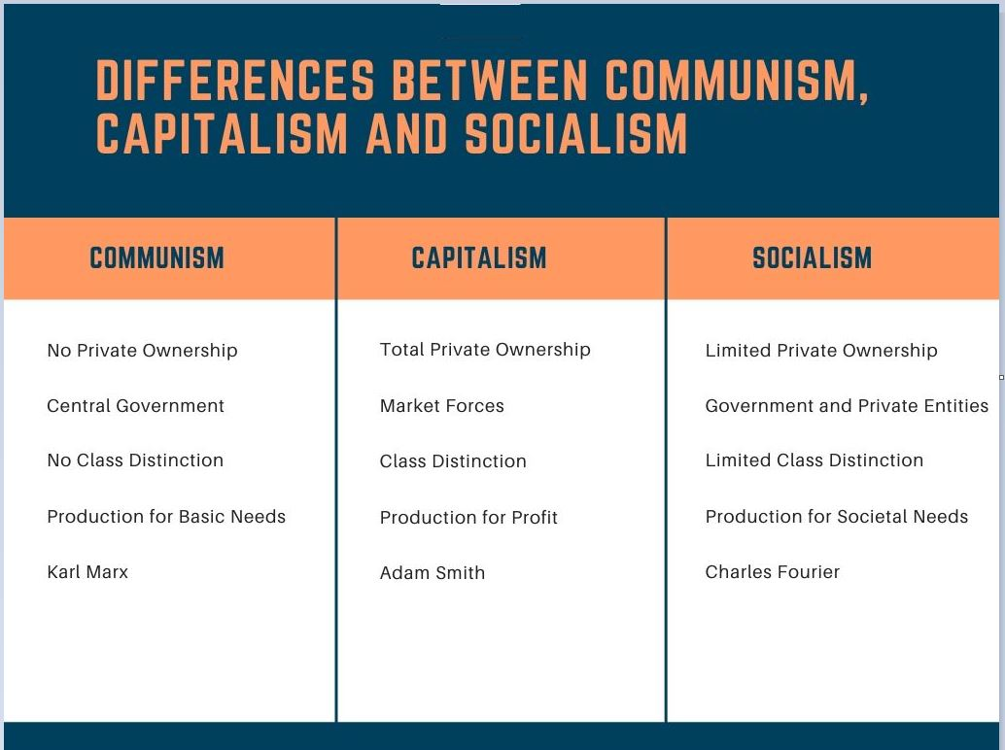
Differences between Capitalism, Communism, and Socialism . . .
Differentiating Factors | Capitalism | Communism | Socialism
Ideology | Maximization of profit by any means necessary. It also believes in Laissez-Faire, a philosophy that emphasizes on leaving circumstances to run their natural course without any external intervention. (Laissez-Faire, i.e.: “Let Do, allow people to do.”; the individual has a natural right to freedom; the physical order of nature is harmonious and a self-regulating system). | From each according to his ability, to each according to his needs. Sounds equitable, sounds good, but fails at every turn throughout history in practice. Suffering is the norm. Elites apparently have ALL the ability and ALL the needs. | From each according to his ability, to each according to his contribution. Not really. (The Elites always live like kings. Everyone else, not so good, suffering is the norm).  Elites apparently have ALL the ability and contribute ALL as they (Receive the lion's share of wealth and freedom).
Economy Planning | In capitalist societies, the economy runs by the functioning of free-markets with individual liberty which brings about innovation and through competition cheapest prices. | The economy is planned by the Central Government to produce for the "Basic Needs" of the people. No individual choice or living a life of luxury. No incentive to innovate. Prices are planned. No competition. Economy stagnates. | The economy is planned by the central government. No incentive to innovate. Prices are planned. No competition. Economy stagnates. Transfer of wealth from rich to poor (from those who chance everything to produce goods or services: time, money, risks given to all "equally" including "slugs" within society that don't work, and produce little or nothing).
Ownership of Economic Resources | Private ownership of economic resources and property is actively encouraged for a free and innovated people with little to no government intervention. | All economic resources are publicly owned and controlled by the government. Individuals hold no personal property or assets. (THE GREAT RESET Devos, Switzerland--World Economic Forum is Communist--"You will own nothing and be happy.") | Individuals can own personal property but all industrial and production capacity is communally owned and managed by a "democratically elected--Not exactly" government. Elected by and for the Elites.
Class distinction | There exists a distinct class whose standing in society is measured by the material wealth in their possession; as well as a middle class who attempts to better themselves and their children; Not all, but a good portion of the lower class lives to receive government benefits, does little to nothing for their own betterment or the betterment of future family members. Mobility within society is active and happens all the time. | Class is abolished. The chances of one worker earning more than the other are nonexistent (The Rulers, those who chose for all of the Communist Society is the Elites who decided who gets what). No mobility in society. The part of society in which you are born you stay. | Classes exist but the differences between them are greatly reduced. It is possible for some people to earn more than others. (Not only possible but definitely happens.) Elites who decided who gets what make much more with all the privileges. Little to no mobility in society. The part of society in which you are born you generally stay.
Religion, Freedom Of: | Up to individual choice. | Religion is abolished. Called by Karl Marx, "An opiate for the masses." Which relieved their souls, their pain. Pain is what the people experience under Communism, so they want the people to feel it to fear their government not to be soothed or better able to withstand against the government. The State becomes the religion of the people. | Freedom of religion is allowed, but overall discouraged. The State becomes the religion of the people.
Welfare | The welfare system—was supposed to be a safety net. To provide minimum basics to encourage people to be self-sufficient, work, acquire individual wealth thus contribute to society. | Supports widespread universal social welfare with an emphasis on public health and education. Depending on your "SOCIAL SCORE," doing what the Government says and demands. If you do what is demanded, you get acceptable benefits. If you do not go along with Government demands, you receive a low Social Score. Benefits are taken away. (There is NO individual liberty). | The state will be for the welfare of everyone in the society without any discrimination. (In theory, but only the Elites are never discriminated against).
Origins | The modern form of capitalism can be traced to the early Renaissance period in the 15th -16th Centuries. The wealthy merchants of Italian city-states engaged in small industry and wage-labor practices at the time. | Although the concept of egalitarian societies existed since the time of Ancient Greece, the foundations of modern-day Communism were established in 1848 by the JESUIT trained MASONIC German Philosopher, Karl Marx (May 5th, 1818 – 14 March 1883). | The economy of the 3rd century BC Mauryan Empire was described by economists as "a socialized monarchy" and "a sort of state socialism".  It became more prominent towards the end of the 18th century and after 1848.
Individual Liberty (Freedoms) | Guaranteed by the United State's Constitution and the Bill of Rights. | None. Government decides on a daily basis. | None. Government decides on a daily basis.
https://www.alemattec.com/Roman Catholic dominated societies which have always been slower economically than Protestant countries .doc

--
Paul (<:) Jesus first!
www.Alemattec.com

