"Your goal should be to bring people to Jesus not Catholicism." - Charlie Kirk
https://x.com/deep_biblestudy/status/1966246146164351274

Charlie Kirk, Smiling in response to his Roman Catholic friend, 'I'm not saying that they're contradictory . . .' Yes, the Truth of Holy Scripture is COMPLETELY contradictory to the false satanic Roman Catholic 'faith' and False Doctrines: Purgatory, Mary Worship, 'pope' Worship, S'Aints', Transubstantiation, their Counsels Curses Upon True Worshipers, Protestants, the 'Mother Church' that persecutes the True Worshipers, Revelation 17:1-6, the True Saints of God, John 4:20-26. Protestants (Protesters of the false, satanic Roman Catholic 'church,') Are Considered Heretics by the satanic Roman Catholic 'church'.

Roman Catholic Doctrine--THERE IS NO GREATER EVIL THAN HERESY! THAN BEING A HERETIC
https://www.catholicapologetics.info/apologetics/protestantism/heretic.htm

The 'Mother Church' i.e.--Rome, Attacking the Heretics, The Protestants--Religion_Overthrowing_Heresy_and_Hatred_Legros
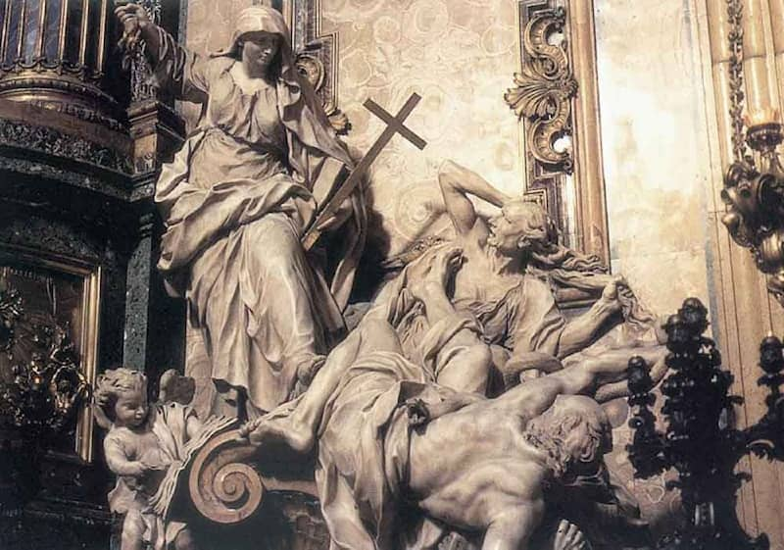
https://www.meisterdrucke.us/kunstwerke/1260px/Pierre_the_Younger_Le_Gros_-_Religion_Overthrowing_Heresy_and_Hatred_c1697_%28marble%29_-_%28MeisterDrucke-169870%29.jpg
The Roman Catholic Religion demonstrated above is a vigorous and distinctly angry young woman (Representing the Roman Catholic 'church,' who through the cross subdues and defeats two figures completely terrorized by the woman – both older men.) Beneath the figure of Heresy, are the two horrified men, and a book which bears Martin Luther's name.
Meanwhile, we see a putto, an satanic angel of Baal, a 'cupid,' tearing pages out of Books by Calvin and Zwingli. Note: Real Angels as revealed in Holy Scripture, the Holy Bible, were ALWAYS grown men.
These 'baby angels' are nothing like the Biblical cherubim—who are extremely powerful, exotic, four-faced beings; there are no baby Angels in All of Holy Scripture.
Some history:
The 'baby angel(s)' are shown in Renaissance art as the putto (plural putti,) Italian vernacular derived from the Latin word for boy, but its origins go much further back to the Greco-Roman world and before. “The conception of the putto reaches back in art to the classical world, where winged infants were physical manifestations of invisible essences or spirits called genius, genii, that were believed to influence human lives. Love putti (erote) were familiars of Eros [or Cupid] and Venus. In Bacchanals, which were celebrations of Dionysius (Bacchus), putti represented fertility, abundance, the spirit of the fruit of life and were often depicted in wild revelry” (Lin Vertefeuille, “The Putto—Angels in Art,” 2005, https://www.ringlingdocents.org/putto.htm). There were other putti associated with fear, dreams, the god Pan, water sprites, music, etc.
Putti disappeared in the Middle Ages, but reappeared in early Renaissance Italy, used then as personifications of human spirit and emotions. They were especially made popular by the artist Donatello, who "gave putto a distinct character by infusing the form with Christian meanings and using it in new contexts such as musician angels," https://en.wikipedia.org/wiki/Putto
Real cherubim as described in Holy Scripture, the Holy Bible:
Genesis 3:24; Exodus 25:19-22; 1 Kings 6:25; 1 Kings 6:28; 1 Kings 7:21-30; 1 Kings 8:6-7; 2 Kings 19:15; 2 Chronicles 3:11-14; Psalm 80:1; Psalm 99:1; Isaiah 37:16; Ezekiel 10:1-20; Ezekiel 11:22; Hebrews 9:1-6
Note: Cubit listed in many different historical sources—ranged from 17½ to 25 inches, but generally believed to be about 18 inches, https://www.britannica.com/science/cubit
Holy, Holy, Holy!
A Christian hymn written by Reginald Heber (1783–1826)
Revelation 4:1-11
Holy, holy, holy! Lord God Almighty!
Early in the morning our song shall rise to Thee;
Holy, holy, holy, merciful and mighty!
God in three Persons, blessèd Trinity!
Holy, holy, holy! All the saints adore Thee,
Casting down their golden crowns around the glassy sea;
Cherubim and seraphim falling down before Thee,
Who was, and is, and evermore shall be.
Holy, holy, holy! though the darkness hide Thee,
Though the eye of sinful man Thy glory may not see;
Only Thou art holy; there is none beside Thee,
Perfect in power, in love, and purity.
Holy, holy, holy! Lord God Almighty!
All Thy works shall praise Thy Name, in earth, and sky, and sea;
Holy, holy, holy; merciful and mighty!
God in three Persons, blessèd Trinity!
https://www.youtube.com/watch?v=P-rdFR9pgvo&list=RDP-rdFR9pgvo&start_radio=1
Council Of Trent
Pope (Saint) Pius V (r. 1566–72) published the new Catechism in 1566 that was ordered by the Council fathers at Trent. It was a large catechism, destined for priests and preachers. It was strikingly more moderate – and less polemically anti-Protestant – than the catechism of the German Jesuit Peter Canisius, the most popular catechism at that moment (Rodríguez and Adeva 1989; Rodríguez and Lanzetti 1982; Bellinger 1970; 1987; also Wandel 2016: 26–27). Pius V also issued a new version of the Breviary (1568) and of the Roman Missal (1570). Both were imposed on all churches and religious orders who could not claim a distinct liturgical tradition of 200 years or older. For the supervision over the implementation of the Roman liturgy, the Congregation of the Holy Rites would later be established (in 1588, under Pope Sixtus V) (Geldhof 2018; 2012; Kranemann 2016). Pius V also made the Inquisition more effective and encouraged a relentless persecution of 'heretics'. He succeeded in eliminating Protestantism in Italy. Right doctrine was now guarded by both the Congregation of the Inquisition and the Congregation of the Index. Under Pius V, the papal court became a model of sobriety and the town of Rome an example for Christianity – comparable to Borromeo’s Milan and even Calvin’s Geneva. Prostitutes were expelled from the Holy City, and Sunday profanation was severely punished. Pius V confirmed priestly celibacy, in line with Trent's modest affirmation of the old regulations in that regard, and against the German princes' lobbying for the admission of married priests.
Gregory XIII (r. 1572–85) changed the mission of papal nuncios: instead of papal legates with an ad hoc mission, they received a permanent assignment, which was not restricted to political matters but also included the local implementation of Tridentine reform. Gregory’s special concern in this regard was Germany (Koller 2016).
His successor Sixtus V (r. 1585–90) issued new protocols for the periodic visits to Rome of bishops from around the world (ad limina apostolorum), bringing with them a report on the state of their dioceses. This proved to be extremely important for the implementation of the Catholic reform. Sixtus V also issued as a rule that provincial councils, which were held everywhere in the Catholic world to implement the council, submit their decisions and decrees to the Congregation of the Council for approval. A former professor of canon law, he believed in institutional reform. He restructured the Roman curia in 1588. He reorganized or created fifteen ‘congregations’, permanent committees of cardinals, six to oversee the government of the Papal States and nine to supervise spiritual affairs. ‘The nine included the Congregations of the Inquisition, the Index, the Council, and Bishops, all of which already existed, as well as Congregations for Regulars or Religious, for the Consistory of Cardinals, for the Signatura Gratiae, which granted papal dispensations, for the Rites, and for the Vatican Printing Press, which Sixtus created to give the papacy its own publication organ’. A thorough reform of the Roman curia, however, did not come to pass: although the lives of popes and cardinals in Rome became far less scandalous, at least since the reign of Paul IV, ‘residence requirements were often waived for papal officials’, e.g. cardinals and nuncios who were bishops, and nepotism and patronage persisted, at least until the end of the seventeenth century (comp. Bireley 1999: 63–64).
Pope Clement VIII (r. 1592–1605) published the official edition of the revised Latin Vulgate Bible, (In response to hearing about King James efforts to publish the Bible that would become known as his namesake.) finally giving execution to a request already formulated at Trent’s Fourth Session (8 April 1546; Delville 2008: 79–80). Pope Paul V (r. 1605–21) eventually compiled into fifty volumes all the materials linked to the council and deposited them in the Vatican Archives under the title fondo Concilio. To Rome’s monopoly on interpretation was now added a restriction on access to the archives. In other words, keeping away the council’s archives from further – let alone critical – study, sealed Rome’s attempts to monopolize the interpretation of its decrees. This embargo remained in effect for about three hundred years, and was only lifted in 1880, when Pope Leo XIII opened the Vatican Archives, but kept a large portion hidden in the Secret Archives of the Vatican. It was only at the beginning of the twentieth century that the Görres Gesellschaft started to publish the council's acts and thus laid the foundation for writing a critical history (Minnich 2023b: 22; O’Malley 2013: 267).
Paul V can be considered the first pope of the Baroque era: he considered the monumental Baroque style as well suited to express the élan of a revived Catholicism, the restored papacy, and eventually of the Church triumphant. He completed the Basilica of Saint Peter, started by Julius II.

Index Librorum Prohibitorum
Index of Prohibited Books
from the
Roman Office of the Inquisition, 1559
https://web.archive.org/web/20010215002338/http://www.aloha.net/~mikesch/ILP-1559.htm#Valla*

The Horrors of the Church and Its Holy Inquisition
https://churchandstate.org.uk/2016/04/the-horrors-of-the-church-and-its-holy-inquisition/

The Catholic Inquisition, Methods Of Torture And Victims
https://churchandstate.org.uk/2025/08/the-catholic-inquisition-methods-of-torture-and-victims/

An Ecclesiastical Harem from Eighteenth-Century Spain
https://www.strangehistory.net/2011/08/21/an-ecclesiastical-harem-from-eighteenth-century-spain/

Bawdy Line. From Sardesais to Ribeiros

The Lusitanisation of Goa’s Hindus has the acclaim of being the most sinister in Christendom
https://www.thehindubusinessline.com/blink/talk/from-sardesais-to-ribeiros/article8253439.ece

Secret history of the Jesuits and 'pope' Francis, the head of the Jesuits . . .
https://www.alemattec.com/Secret history of the Jesuits and 'pope' Francis, the head of the Jesuits . . .htm
https://www.Alemattec.com/The Secret History Of The Jesuits--Paris.pdf

EIGHTY POPES TORTURED AND KILLED some 50 MILLION (plus) -- . . .
https://www.alemattec.com/EIGHTY POPES TORTURED AND KILLED some 50 MILLION (plus) -- . . .htm
Number murdered by the papacy. Also, Calvinist, Puritans, Huguenots, Waldenses and Albigenses all taught the pope was 'the antichrist,' and the church of Rome Babylon.doc
https://www.Alemattec.com/Number murdered by the papacy. Also, Calvinist, Puritans, Huguenots, Waldenses and Albigenses all taught the pope was 'the antichrist,' and the church of Rome Babylon.doc

Charlie Kirk--A Defender Of The Faith! NOT The Faith Once Delivered To The Saints, Jude 1 Verse 3--But The satanic Roman Catholic Faith, 17SEP25 . . .
https://www.alemattec.com/Charlie-Kirk--A-Defender-Of-The-Faith!-NOT-The-Faith-Once-Delivered-To-The-Saints,-Jude-1-Verse-3--But-The-satanic-Roman-Catholic-Faith,-17SEP25.htm

--
Paul (<:) Jesus first!
www.Alemattec.com

