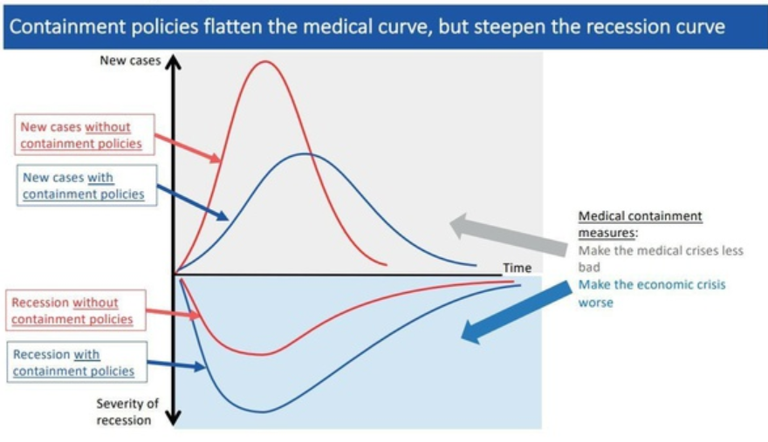

The plan, the Great Reset, looks like a five year plan using the World Bank's financing of $4,000,000,000 and ending March 31, 2025.
https://documents1.worldbank.org/curated/en/993371585947965984/pdf/World-COVID-19-Strategic-Preparedness-and-Response-Project.pdf
Pages #1-5.

George Orwell's 1984 is being played out before our very lives. TOTAL CONTROL!--Planet Lockdown Documentary Film--'Having the courage to face our fear,' January 19, 2021 . . .
https://www.alemattec.com/George-Orwell's-1984-is-being-played-out-before-our-very-lives.-TOTAL-CONTROL!--Planet-Lockdown-Documentary-Film--'Having-the-courage-to-face-our-fear,'-January-19,-2021.htm

Leaked CDC memo raises new Delta variant concerns
Evidence is mounting about the dangers of the Delta variant and how mask-wearing is essential to bring it under control, according to an internal CDC document.
'We've got a bigger challenge' »
Yahoo! News had the above "hook" headline, to "hook the reader's interest in reading the story about a so called "leaked" memo (What the CDC knows but isn't telling us)". Since it is "leaked" and NOT OFFICIALLY communicated it can be 100% factually wrong, the CDC can then use deniability when the PLANDEMIC is over, but the message is out to the world! THIS VIRUS IS A REAL KILLER; DOESN'T FOLLOW NORMAL VIRUS BEHAVIOR AND SOMEHOW MADE IT SELF MORE DANGEROUS BY ITS MUTATION AND IS GOING TO KILL THE unVACCINATED! (Vaccinated don't get killed but can transmit the virus; therefore, they must mask up). The Vaccinated must mask up because of the unVACCINATED's unpatriotic, selfish, 'science denying' conspiracy loving Christian behavior! This is an unVACCINATED pandemic, the head of the CDC stated.

'The war has changed': Internal CDC document urges new messaging, warns delta infections likely more severe
https://www.yahoo.com/news/war-changed-internal-cdc-document-235139094.html

CDC head says COVID-19 is becoming 'pandemic of the unvaccinated'
https://www.upi.com/Top_News/US/2021/07/16/COVID-19-vaccinations-Rochelle-Walensky/6691626467199/

We shouldn’t worry when a virus mutates during disease outbreaks
https://www.nature.com/articles/s41564-020-0690-4

How did CHINA manage to eradicate the virus altogether from their population.
Social-distancing, forced-mandated 'self-quarantine,' medical care, etc., are alright. They can reduce or CONTAIN the spread. All infected people, I suppose, either died or got cured (with lifelong immunity hereafter).

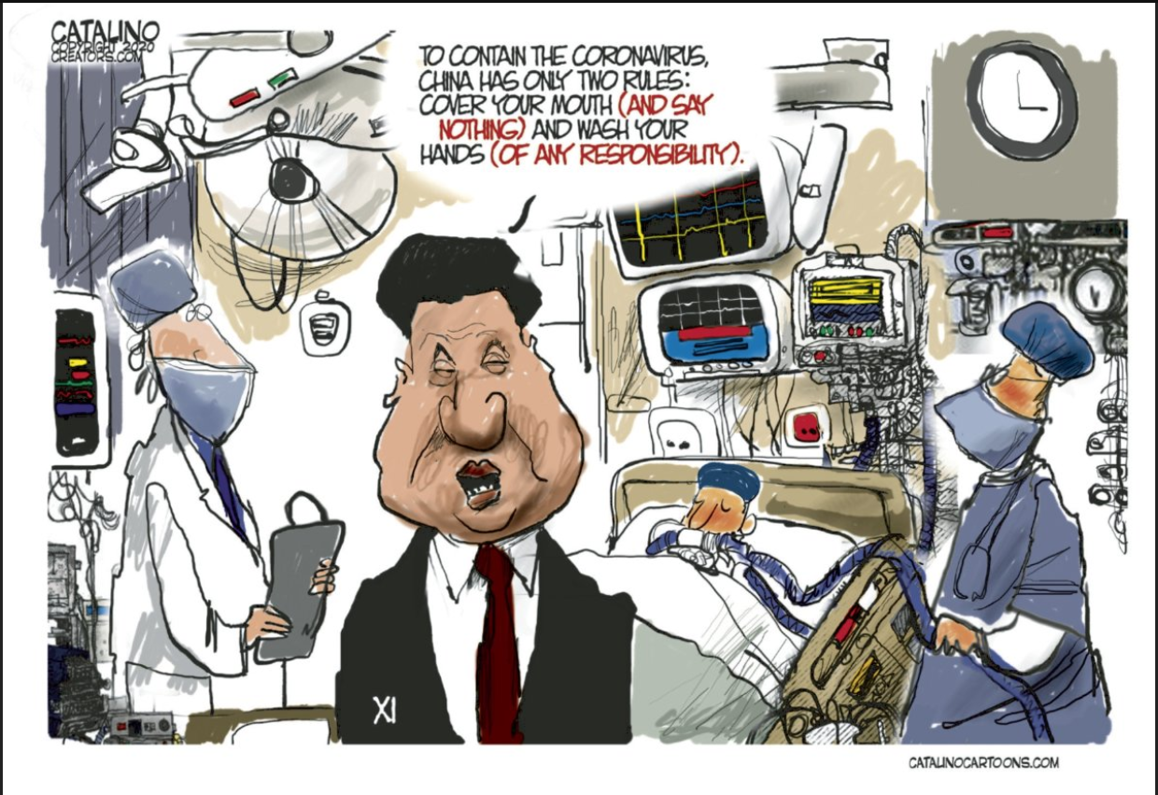

Zero INFECTED PEOPLE?
Wow, with such certainty . . .
They closed the Hospitals.
Relieved the Healthcare Staff.
Isn’t it a little too early to declare that it was all over. For sure?

China shuts all temporary coronavirus hospitals in city of Wuhan - state media
March 10, 2020
https://www.reuters.com/article/us-health-coronavirus-china-wuhanhospita-idUSKBN20X0RT
Look at all the mathematical modeling that the western Universities are throwing at us. Look at the time, they predict, it would take for any other nation to go to NEAR-zero infected.
I have a strong suspicion that there is more to it than what we are being told.
Did you ever hear anyone asking China this question? How you eliminated the virus?
And, why NOT?

A Year After Wuhan, China Tells a Tale of Triumph (and No Mistakes)
The Chinese Communist Party’s efforts to hide its missteps have taken on new urgency as the anniversary of the world’s first Covid-19 lockdown nears.
https://www.nytimes.com/2021/01/10/world/asia/wuhan-china-coronavirus.html

Hmmmm. Doesn't make sense, does it? Within four months, in a country of over a billion people . . . this!

The Latest: 11 New COVID-19 Cases in China's Lone Outbreak
Chinese officials say 11 more people have been diagnosed with COVID-19 in a southwestern city bordering Myanmar that is the scene of China’s current sole active outbreak.
April 7, 2021
https://www.usnews.com/news/world/articles/2021-04-07/the-latest-india-sees-another-record-day-of-new-virus-cases

Two more things that doesn't seem to make sense in a rational world . . .

1. China was a little too prepared for this “unexpected” EVENT.
Two HUGE Green-field Hospitals built within days?

In pictures: China is building two hospitals in less than two weeks to combat coronavirus
https://www.cnbc.com/2020/01/31/pictures-china-builds-two-hospitals-in-days-to-combat-coronavirus.html

The kind of 100% lock-down they had within days from their START date.
Why such an urgency?
There was no precedence (of such drastic measures in history).
There was no such DIRE forewarning from the WHO or any Western University or national Medical Agency, such as CDC.
So WHY, then, such extreme measure in the FIRST leap?
Look at the scale of tight geographic containment of the epidemic within China.
If the virus could spread to Italy and Spain within a couple of weeks, how come it didn’t reach Beijing?
Industrial lock-down at such enormous cost and obvious threat of losing Western Markets?
Did you hear them being tentative EVER in this the build-up to this containment?

We know China knew much more about this virus that came from a 'wet market' as they propose than they told the world through the papacy controlled United Nation's World Health Organization, WHO.

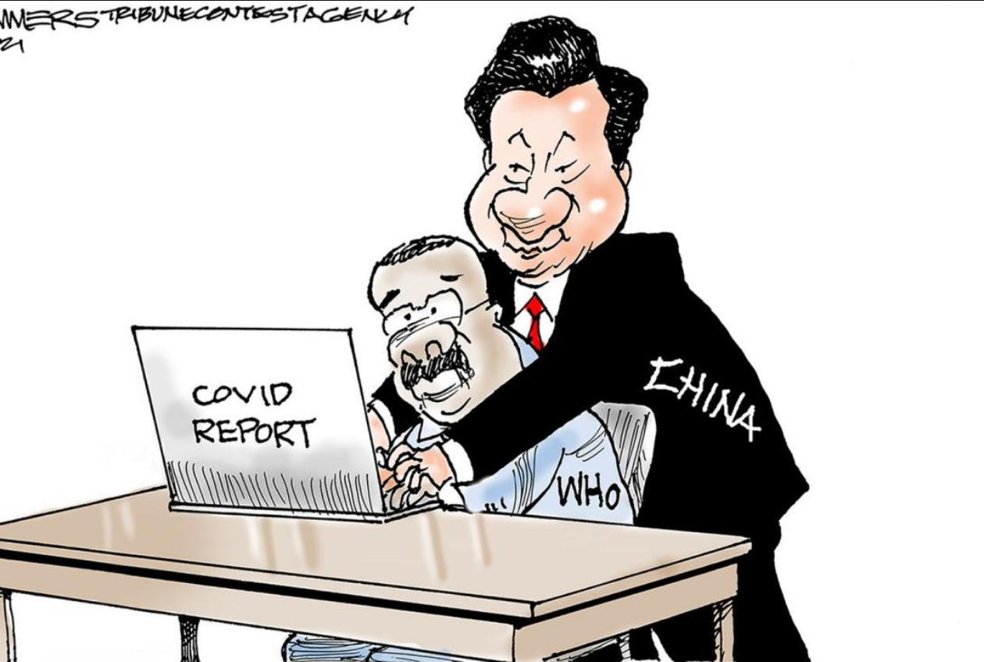

We know China knew much more about this virus that came from a 'wet market' as they propose than they told the world.

Additionally, add to this China's interference in every aspect of American Society . . .
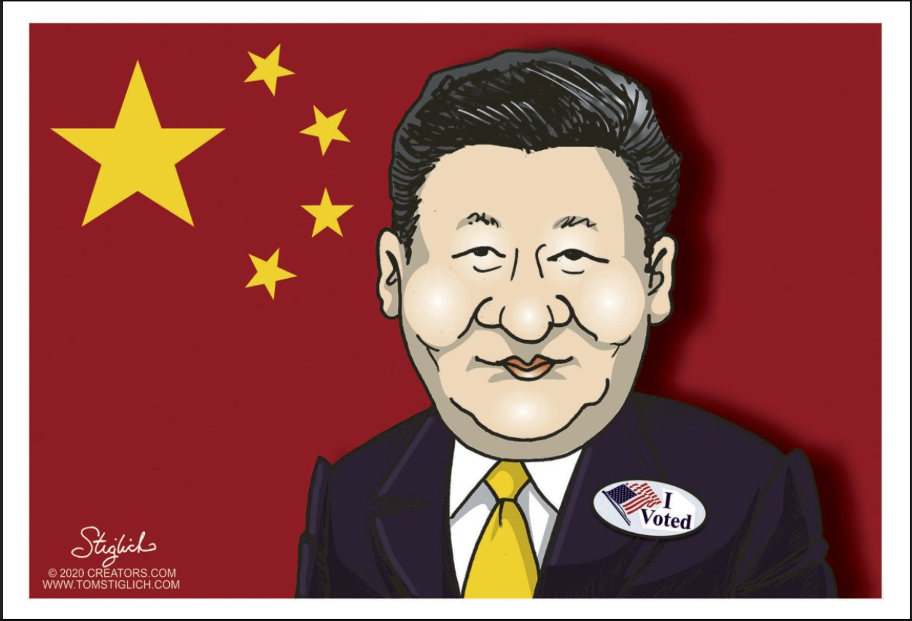
2. Remember the Chinese Doctor who first reported the NEW virus?
He was first bullied by the police.
And then, he died pretty too quickly (citing COVID as the cause of his death).
Did we hear about any of his work expert work being done in Wuhan (before the Corona outbreak and after)?

'An Eternal Hero.' Whistleblower Doctor Who Sounded Alarm on Coronavirus Dies in China
https://time.com/5779678/li-wenliang-coronavirus-china-doctor-death/

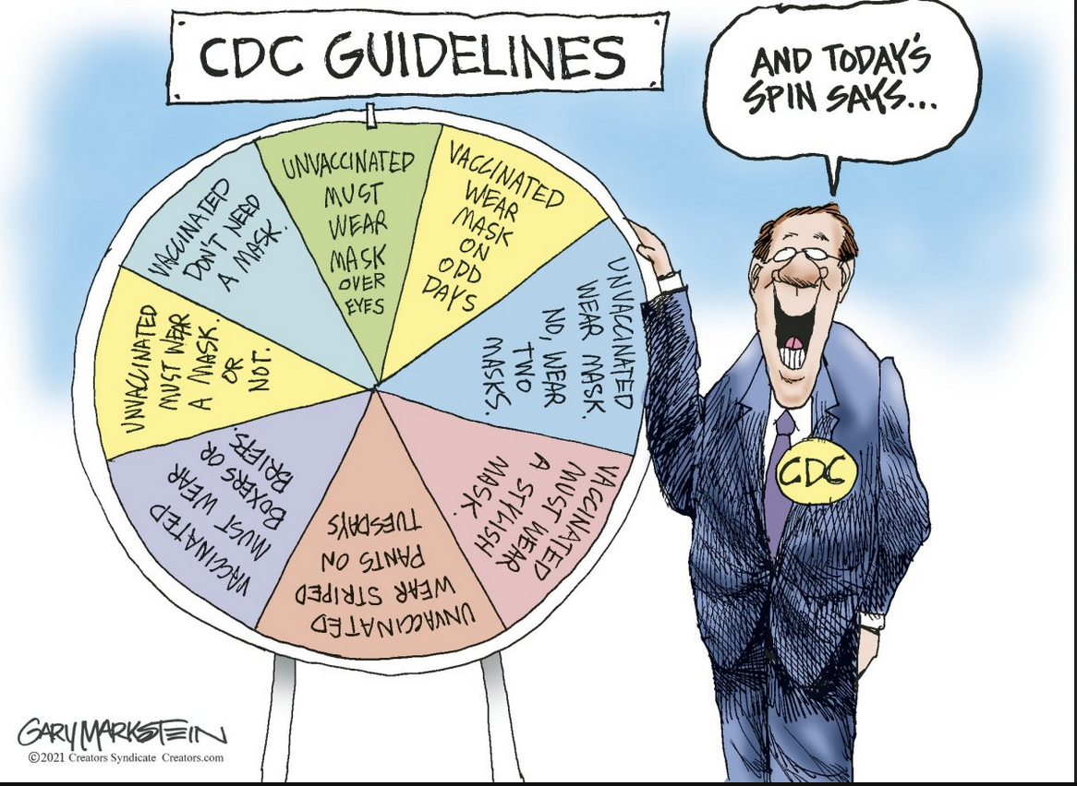

China has built itself so that the papacy, American “woke” corporations, large controlling Tech. companies, the media, FBI, CIA, HHS, Democrats/Republican leadership, Communist Governors, Mayors, Prosecutors, universities, news media, athletes, teacher's unions, work with and sing its praises all the while tearing down and belittling the United States of America as racist; push to specifically cause racial disharmony all the while working with China to overthrow our Constitutional Republic.

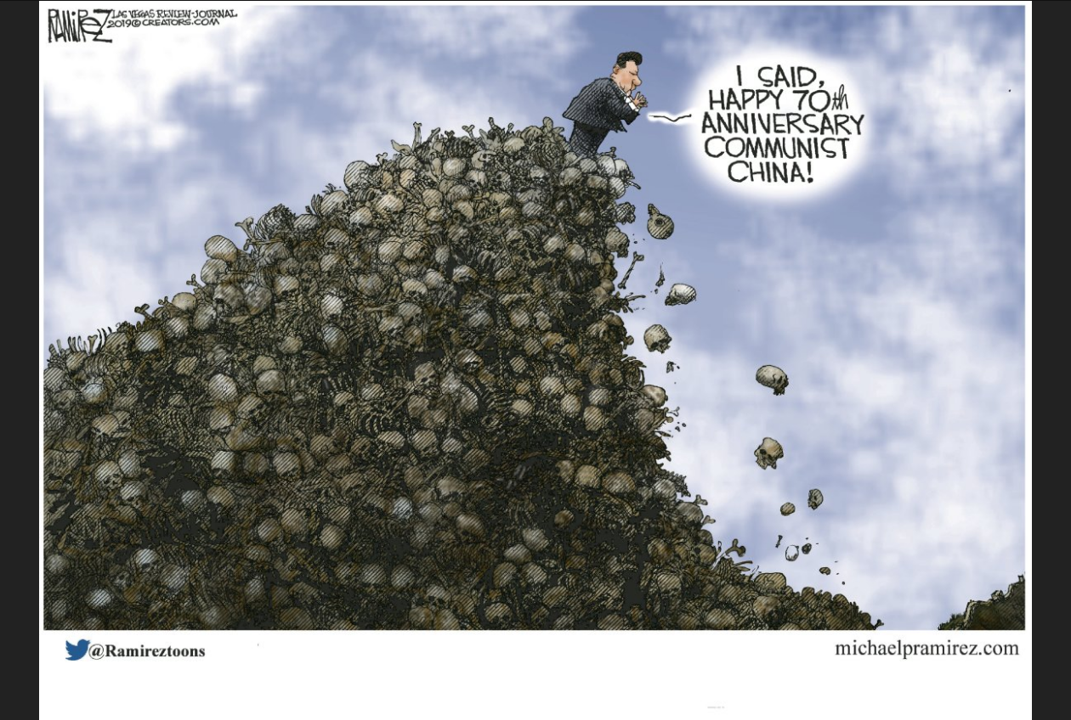

--
Paul (<:) Jesus first!
www.Alemattec.com

